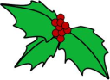
1. People like to eat
__ H O __ __ __ __ __ __.
2. Santa Claus visits many
H O __ __ __ during Christmas.
3. Deck the halls with bows and H O __ __ __.

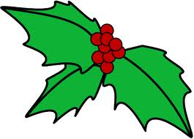
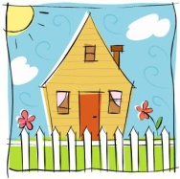
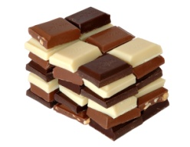
6. Kids should have
__ H O __ __ __.
5. At Christmas you should
H O __ __ __ __.
4. Some kids want a
H O __ __ __ __ for Christmas.


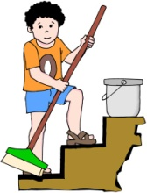
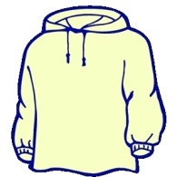
9. Everybody __ H O __ __ at Christmas.
8. A group of persons who sing in unison is called a
__ H O __ __ __.
7. People go to a H O __ __ mass at Christmas.

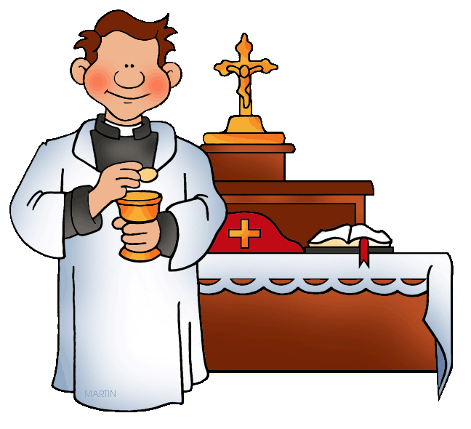

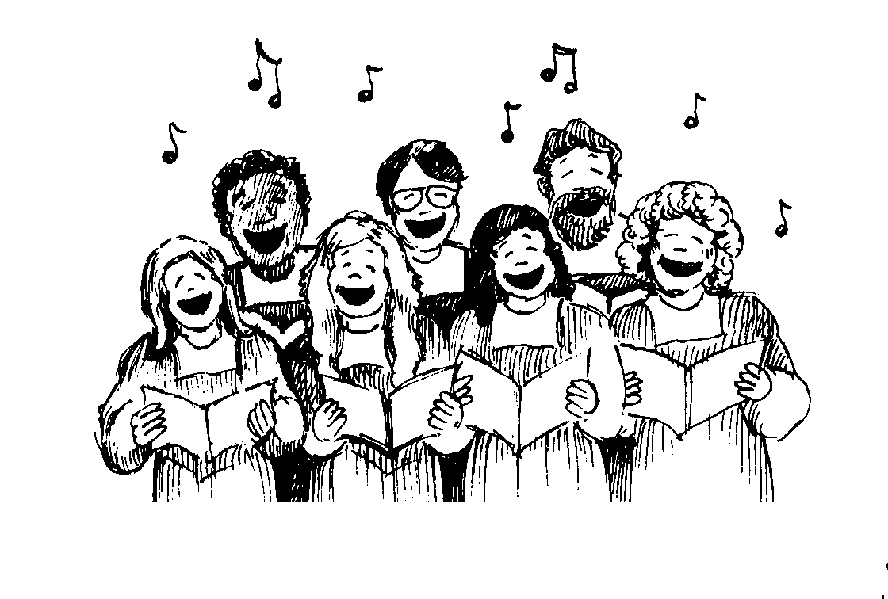
12. Sometime you tell __ H O __ __ stories t Christmas.
11. Students perform a __ H O __ at school.
10. You can take a lot of __ H O __ __ __ at Christmas.

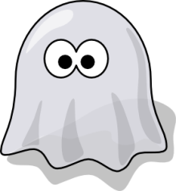
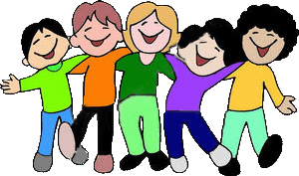
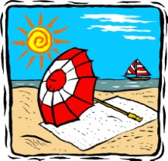

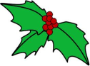
15. In Australia Christmas is H O __.
14. Santa delivers presents in the early H O __ __ __ of night.
13. You should do your
H O __ __ __ __ __ __.

