AUTUMN FESTIVITIES

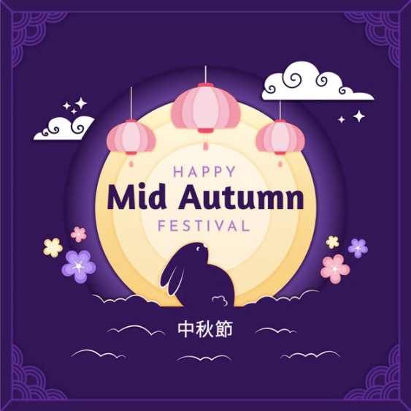
The Moon festival
Why did Hou Yi become a national hero?

Who took the elixir in the end? What was the result of that action?

How do Chinese people celebrate the Mid-Autumn Festival?

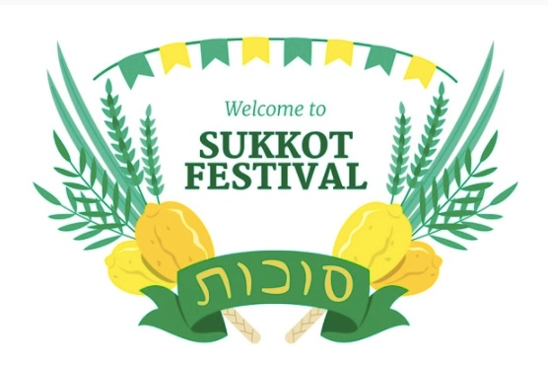
Sukkot
What are three things you do on Sukkot?

How do some families decorate their sukkah?

What’s the most important part of the sukkah?

Did you know about these festivities? Choose one to learn more about it!

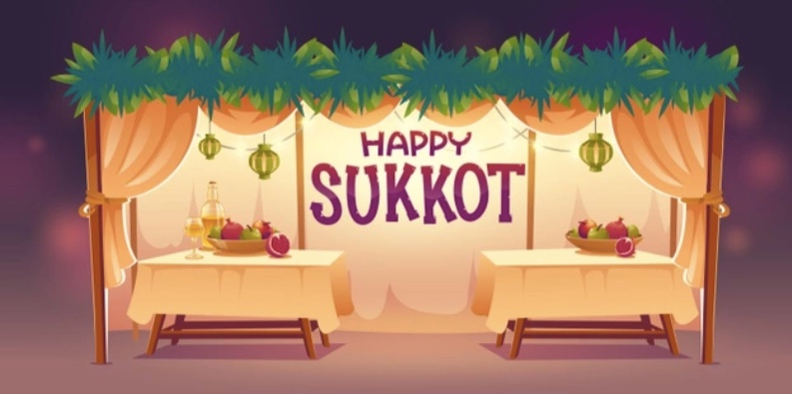
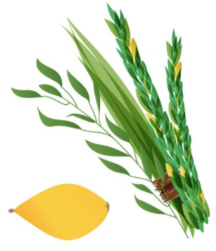
YOU CHOSE SUKKOT!
Extra info
On Sukkot, Jewish people use four kinds of plants known in Hebrew as the Arbah Minim (the ‘four species’). They represent the unity of Israel, and the harvest. They are:
Aravot: willows that have no fruit and no fragrance
Lulav: palm branch that has no fragrance, but has fruit which can be eaten
Etrog: citron, a fruit like a lemon, that has a sweet fragrance and can be eaten
Hadassim: myrtles, that have a nice smell but cannot be eaten
The myrtle twigs, the willows and the palm branch are tied together. This bouquet is called the lulav.
Watch the video and learn more:
https://www.youtube.com/watch?v=CK-0c50Si5w

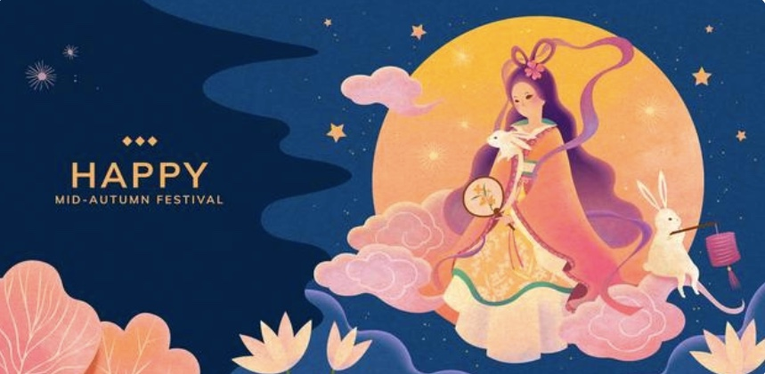
YOU CHOSE THE MOON FESTIVAL!
Short story
Three immortals, pretending to be old beggars, went through the forest asking for food. The fox and the monkey quickly offered them food. The rabbit had no food but she was very pious. She said, “I’m so sorry I couldn’t offer any food to help you, but I can give myself,” and jumped into the fire.
The immortals were moved by the rabbit’s sacrifice, and decided to make her an immortal, sending her to live in the Moon Palace with Goddess Chang E.
Watch the video and learn more:
https://www.youtube.com/watch?v=fpVd822yr7M

