British festivals: Complete the names of the festivals.
- …………………………………………………
- Listen and tick the words in the box you hear. They are not in order.
 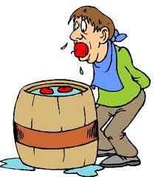 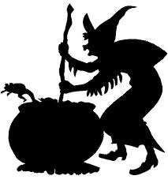 labbel the pictures with words from the box

Witch -candies - pumpkin -evil spirits - monster - trick or treat -cake - black pointed hat -candle -window - masks - broomstick -ghosts -apple bobbing- sweets- black cloak- costumes-

- Describe three traditions people do on Halloween. Use the words in the box to help you
1 …………………………………………………………………………………………………………………………………………………
…………………………………………………………………………………………………………………………………………………….2 …………………………………………………………………………………………………………………………………………………
……………………………………………………………………………………………………………………………………………………
3 ………………………………………………………………………………………………………………………………………………..
…………………………………………………………………………………………………………………………………………………….

II- …………………………………………………………………………
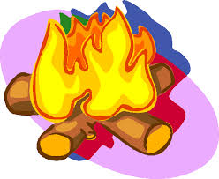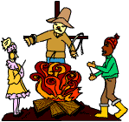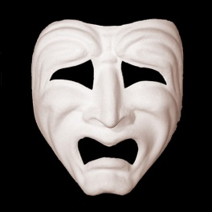
labbel the pictures

- Complete the description with the words you hear.
It’s ……………………………………………….. the 5th. And I’m building a ………………………… to commemorate the Gunpowder Plot. We’ve got …………….……………………… that we’ve saved for a …………………………….
This is the …………………………………….. .We’re going to …………………………… him on the bonfire. You take man’s clothe and you stuff it with ………………………………….., , then you draw a ……………………….. and there you are: a …………………………………
“A ……………………………….. for the guy?” this is to get more …………………….. for the fireworks.

- Listen and answer.
- Who was Guy Fawkes? ……………………………………………………………………………………………………………………………
- When did he live?.......................................................................................................................................................................
- Who was the king of England at that time? …………………………………………………………………………………………
- Why did Guy Fawkes want to kill the king?........…………………………………………………………………………………….
- How did they decide to kill the king? …………………………………………………………………………………………………..
- Did he succeed? ……………………………………………………………………………………………………………………………………..
- What did the king do to Guy Fawkes? ……………………………………………………………………………………………………
- How do people commemorate this day? ………………………………………………………………………………………………
- What Happens in Louis, Sussex? ……………………………………………………………………………………………………………
………………………………………………………………………………………………………..
- ……………………………………………………………………………..

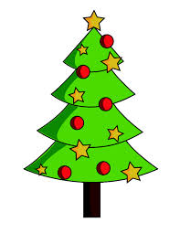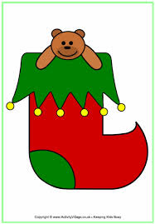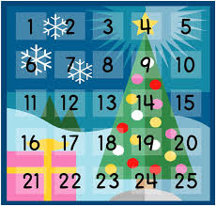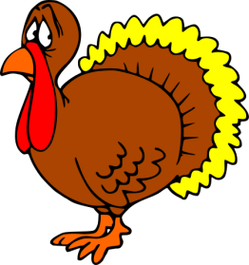

labbel the pictures
- Complete the sentences about ……………………………… in the passive form. Past or present.
- An advent calendar …………………………….. in Christmas. (use)
- A window of the calendar …………………………………… every day before Christmas. ( open)
- The houses ……………………………………… with Christmas trees, cards and stockings. (decorate)
- The idea of Christmas trees ……………………….. in Germany in the 19th. century. (start)
- The presents …………………………………… by Father Christmas or Santa Claus. (bring)
- The presents …………………………………… in stockings. (leave)
- Father Christmas ………………………………………………by reindeers. ( bring)
- On Christmas Day, a turkey………………………………………….., (cook)
- The turkey ………………………………………… with vegetables, gravy, stuffing and roast potatoes. (serve)
- Then, Christmas crackers containing bad jokes and paper hats…………………………………. (open)
- For desert a Christmas pudding ………………………………………… with cream and brandy sauce.
- After dinner, the presents …………………………………………… (open)

