
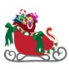
8 + 12 + 19: First letter of this illustration.
4: The seventh letter of the alphabet.
1: The first letter in
2

1

-to find out solve the puzzle!
3


5: First letter of the alphabet.
3 + 7 +13+ 24: First letter of the language used in this task.
4


5

6: First letter of this illustration.
6


2: The first letter of this illustration.
7

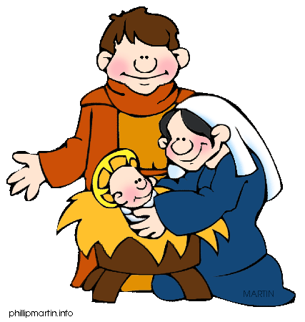
8

14: The first letter of these Christmas things.
I
9
25: Second letter of this illustration.

10
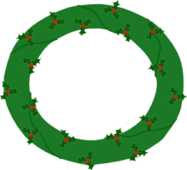
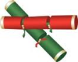
16 + 22: The third letter of this word.
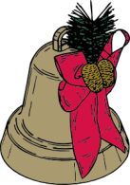
11

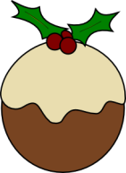
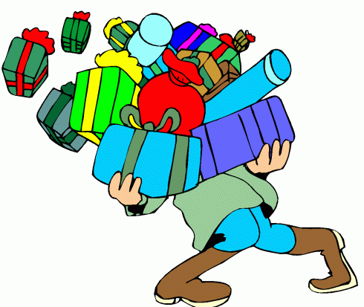

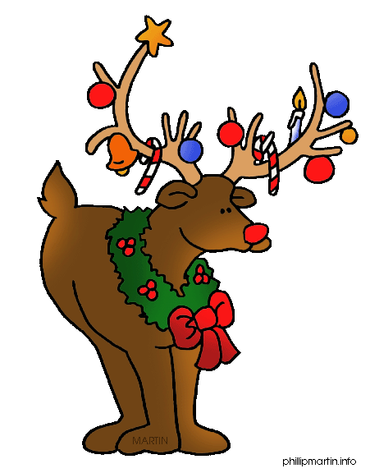


17 + 23: The third letter of this word.
11: The seventh letter of the things the man carries in the picture.
18: Letter number four in this thing we all want for Christmas.
21: Fourth letter in the name of this reindeer.
15 + 20: Letter number 4 in this word.
10: First letter of this Christmas stuff.
25
24
23
22
21
20
19
18

17

16

15

14

13

12

