WECHSELSPIEL
Wo ? Wohin ? Was ? Wie ?

 | Britta | Jens | Karsten | Margit | Martin
Wo ? |  |  |  | 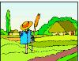
Was ? (1) | 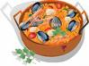 |  | 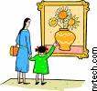 |  | 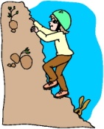
Was ? (2) |  | 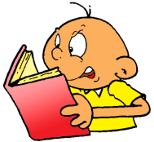 |  |  | 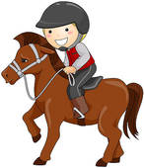
Wohin ? | 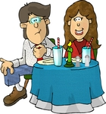 |  |  | 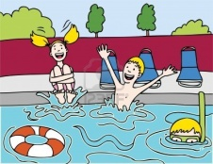 | 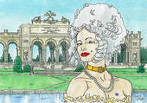
Wie ? |  | Ø | 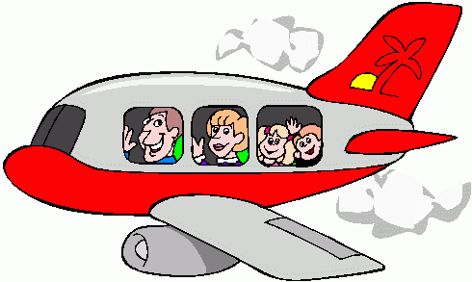 | 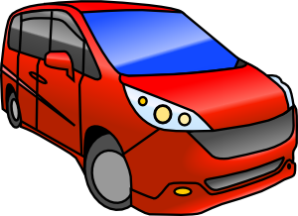

WECHSELSPIEL
Wo ? Wohin ? Was ? Wie ?

 | Britta | Jens | Karsten | Margit | Martin
Wo ? | 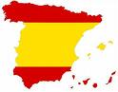 |  | 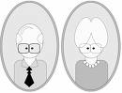 |  | 
Was ? (1) |  | 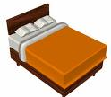 |  | 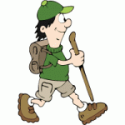
Was ? (2) | 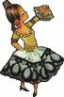 |  | 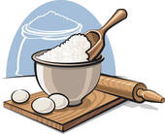 | 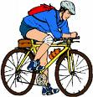
Wohin ? |  | 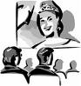 | 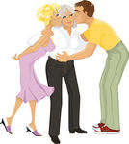
Wie ? | 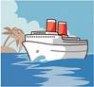 | Ø |  |  | 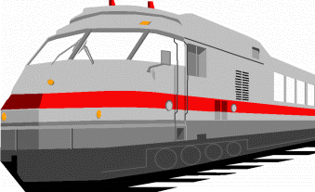

WECHSELSPIEL
Wo ? Wohin ? Was ? Wie ?

 | Britta | Jens | Karsten | Margit | Martin
Wo ?
Was ? (1)
Was ? (2)
Wohin ?
Wie ? |  | Ø

WECHSELSPIEL
Wo ? Wohin ? Was ? Wie ?

 | Britta | Jens | Karsten | Margit | Martin
Wo ?
Was ? (1)
Was ? (2)
Wohin ?
Wie ? |  | Ø

