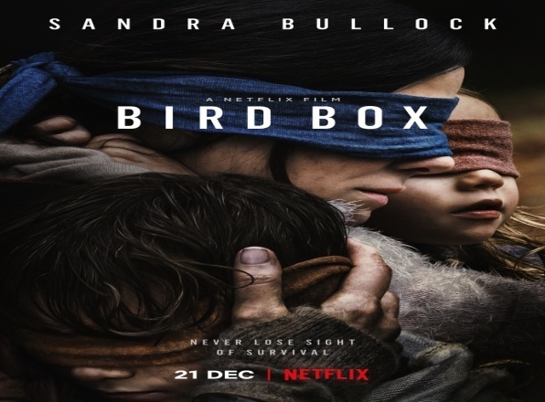
Bird Box(2019) is a horror film starring Sandra Bullock, John Malkovitch and Trevante Rhodes among others. It is set in a care center building. It is about a pregnant woman who goes to a prenatal appointment and is caught up there with a brave construction worker and a bad-mannered drunk. They decide to stay in the building as a mysterious force causes the suicide of the people who catch sight of it. Five years later after surviving this traumatic experience, Malorie the character portrayed by Sandra Bullock is now the mother of 5-year-old twins who have no name because Malorie thinks the world is too cruel to bear names that bind us to it.
Vocabulary
Care center(L3):centre de soins
Pregnant(L4) :enceinte
Caught-up(L5) :Coincée, bloquée
Drunk(L7) :Ivrogne
Catch sight of(L9) Voir
A-Read the film synopsis and do the crosswords
Across 1.The effects of the mysterious force
2.The genre of this film
Down 1.The character played by Sandra Bullock
2.One of the people who are caught up in the care center

B-True or False? Justify with a word or expression from the synopsis
1-Malorie is caught up in her bedroom True/False
2-A vampire causes the death of the people who see it True/False
3-The children of Malorie have no identity True/False
4-Malorie’s opinion on the world is positive True/False

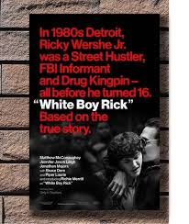
White Boy Rick(2019) is a story based on reality. It’s a drama and biopic. Rick is played by Richie Merritt. Matthew McConaughey portrays Rick Wershe Sr., the father of Rick. The story is set in the violent and rat-infested city of Detroit. It is about Rick Wershe Jr, nicknamed ‘White Boy’, an adolescent who drops out of school and becomes a drug dealer. But the gang that sells this drug to Rick ignores he informs the FBI on their criminal activities. The father of Rick who illegally sells rifles is not glad to know that his son helps the police arrest drug dealers and tensions will appear between them.
Nickname(L6):Surnommer
Drop out of(L6):Abandonner
Rifles(L10):Fusils
Across 1.The actor who portrays Rick
Down 1.The organization informed by Rick
2.What the father of Rick sells
3.The setting of this film

A-Read the article and do the crosswords

B-Answer these questions
1-When did Rick drop out of the school?

2-What information have you got on the city of Detroit?

3-What is the cause of the tension between Rick and his dad?

