FUTURE PLANS: GOING TO
A) Look at Barry’s plans for the weekend and form sentences about what he’s going to do. 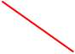

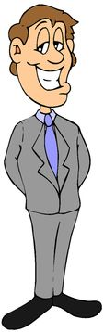
1
2
3
4

5
6

B) Turn the sentences into the future (going to) Use future expressions we’ve seen in class

a. We watch tv every morning ___________________________________________________________
b. She reads the paper every day ____________________________________________________________
c. Do you clean your bedroom every morning? ____________________________________________________________
d. My sister doesn’t take the rubbish out every night _____________________________________________________________
e. Where does your father have lunch? _____________________________________________________________
f. She travels to USA with her boyfriend _____________________________________________________________

C) Imagine you are a famous person (movie star, singer, sportsman/woman, etc.). Write about your job and about your future plans and future desires/ambitions.

_______________________________________________________________________
_______________________________________________________________________
_______________________________________________________________________
_______________________________________________________________________
_______________________________________________________________________
_______________________________________________________________________
_______________________________________________________________________
_______________________________________________________________________
_______________________________________________________________________
_______________________________________________________________________
_______________________________________________________________________
_______________________________________________________________________
_______________________________________________________________________
_______________________________________________________________________
_______________________________________________________________________
_______________________________________________________________________
_______________________________________________________________________
_______________________________________________________________________

