- I’m going to go there with my friends on Saturday afternoon.
- ____________________________________________________
- ____________________________________________________
- ____________________________________________________
- ____________________________________________________
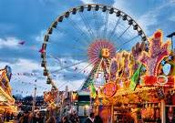
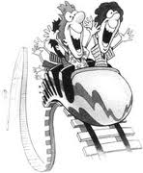

- My sister’s going to go there on Saturday morning.
- ________________________________________________________
- ________________________________________________________
- ________________________________________________________
- ________________________________________________________

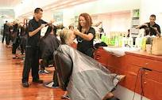


- I’m going to go there with some friends on Sunday afternoon.
- ________________________________________________________
- ________________________________________________________
- ________________________________________________________
- ________________________________________________________
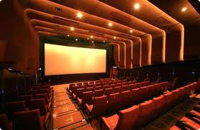


- My brother’s going to go there with some friends on Friday evening.
- ________________________________________________________
- ________________________________________________________
- ________________________________________________________
- ________________________________________________________
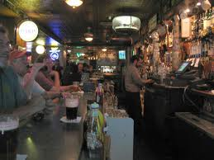


- I’m going to be in this place on Saturday morning.
- ______________________________________________________
- ______________________________________________________
- ______________________________________________________
- ______________________________________________________



- My mother’s going to go there on Saturday morning.
- ____________________________________________________
- ____________________________________________________
- ____________________________________________________
- ____________________________________________________
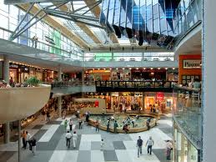


- I’m going to go there with my family on Friday evening.
- ______________________________________________________
- ______________________________________________________
- ______________________________________________________
- ______________________________________________________
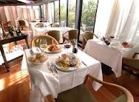


- My parents are going to go there on Saturday evening.
- __________________________________________________________
- __________________________________________________________
- __________________________________________________________
- __________________________________________________________
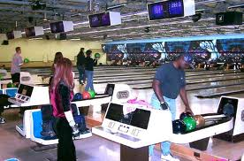


Activity 1:
Students work in pairs or small groups and try to complete the sentences 2 to 5 in one or more of the cards above (depending on the number of students you have!) using the going to form and original ideas connected to the place they can see in the picture.
Remind them to pay attention to the subject they are given in the card (for the agreement subject-verb)
Make sure more than one group or pair has the same card of a specific place, so that when the activity is finished your students can decide which one has been the most imaginative.
Activity 2:
Read out this situation to your students:
“Your mother needs to buy some things, but she has to take care of your little brother and she cannot leave home. So, she has written a list of the things she needs and she has given it to you. (HERE, give your students a copy of the list) As you can see your mum’s list is particular, because she has not written anything on it. Instead, she has included pictures of what she needs.”
Look at them. What are they and where are you going to go to buy them? Complete as in the example and…have fun!!


Example: I’m going to buy some buttons at the haberdashery.

1
2

3

4 
5 
6 
7 
8 
9 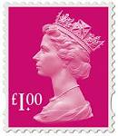
10

- I’m going to buy___________________________________________
- I’m ____________________________________________________
- I______________________________________________________
- _______________________________________________________
- _______________________________________________________
- _______________________________________________________
- _______________________________________________________
- _______________________________________________________
- _______________________________________________________
- _______________________________________________________

Answers:
- I’m going to buy some bread at the bakery.
- I’m going to buy an aubergine at the greengrocer’s.
- I’m going to buy a hammer at the hardware shop.
- I’m going to buy a baby bottle at the chemist’s.
- I’m going to buy some flowers/a bunch of flowers at the flower shop.
- I’m going to buy a newspaper at the newsagent’s.
- I’m going to buy a kilo of mussels at the fishmonger’s.
- I’m going to buy a box of colouring pencils/crayons at the stationery.
- I’m going to buy some stamps /a book of stamps at the post office.
- I’m going to buy half a kilo/ some sausages at the butcher’s.

Note:
Tell students they cannot go to a supermarket for any of these things. In this way they can practise the name of specific shops for specific items.

As I said in “Going to…places in town!” (1/5), I’ve used going to go with my students even if the most used form is only going to when the verb go is used in these cases. I’ve done so to stop them from confusing the present continuous with the going to form.

You can ask your students to name some other items they can buy in the shops used in “Activity 2”.

