Wrong
fever
terrible
rest
worry
juice
better
feeling
medicines
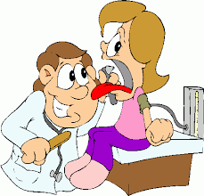
A foot pain/a stomachache/a fever/an earache/a toothache/a backache/a headache/a sore throat
7th Form
GROUP SESSION ACTIVITIES: What’s the matter?
1)Label the pictures below with words from the list

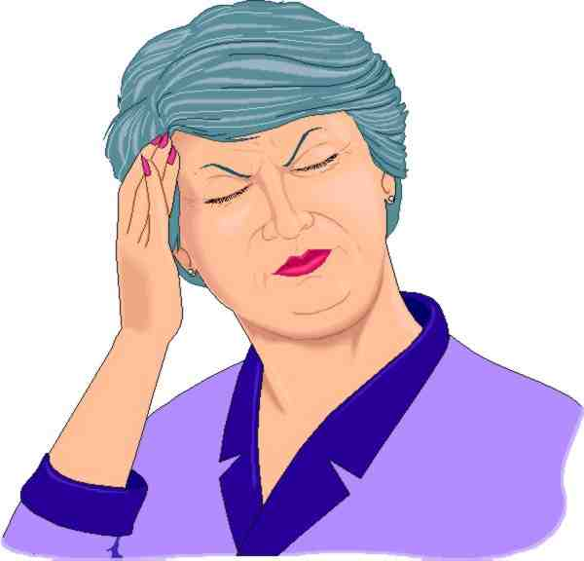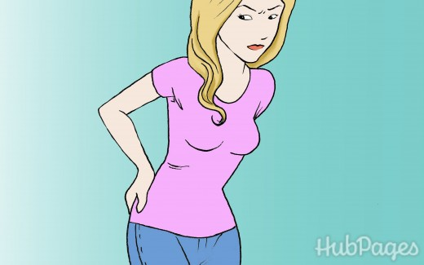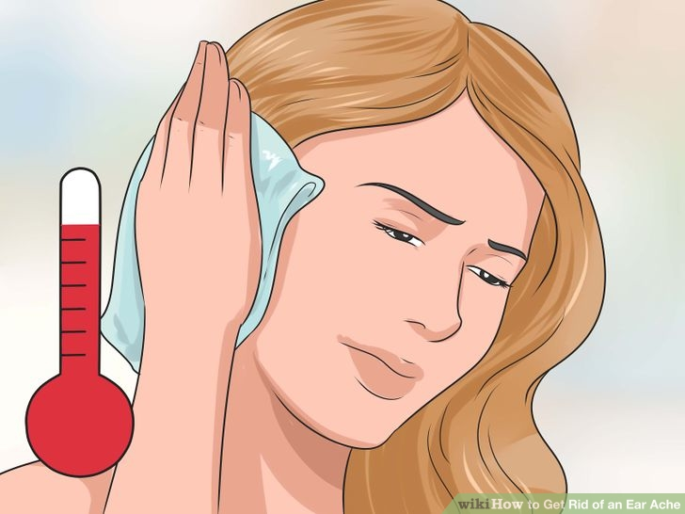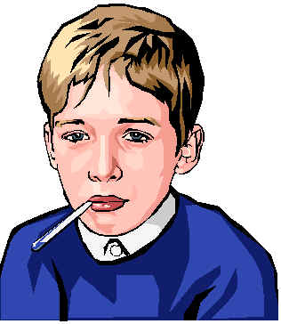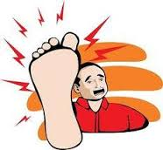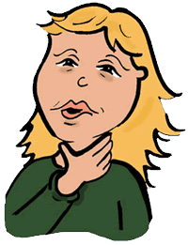
……………………….. …………………… ……………………. …………………. …………………. …………………… ………………….. ……………………..
2)Grammar rules: have+noun fell+adjective
I have a headache we have a stomachache she has fever My father has a backache
I feel sick she feels terrible you don’t feel well How do you feel?
3)Complete the following dialogues with feel or have
*Hi Sarah . How are you?
*I ………………………… terrible.
*What is the matter?
*I ………………………… a headache and a sore throat.
*That is too bad. Do you …………………….. fever?
*Yes. I ………………………….. a high temperature.
*You must see a doctor.
4)Fill in the blanks with words from the list
D Hello sarah.How are you …………………………….. today?
S I don’t fell well.
D What’s …………………………? Can you tell me how you feel?
S Well I have a …………………………… headache.
D Does your throat hurt?
S Yes, and I have a cough too.
D Do you have ………………………….?
S Yes.
D It seems like you have the flu.
S That is terrible.
D Don’t……………………... I will give you some…………………………. and you will fell ………………………soon.
S Can I go to school tomorrow?
D No. Stay at home, get some ……………………… drink plenty of ……………………….. and water.
S Thank you doctor.
5)Write your own dialogue between a patient and a doctor.
……………………………………………………………………………………………………………………………………………………………………………………………………………………………………………………………………………………………………………………………………………………………………………………………………………………………………………………………………………………………………………………………………………………………………………………………………………………………………………………………………………………………………………………………………………………………………………………………………………………………………………………………………………………………………………………………………………………………………………………………………………………………………………………………………………………………………………………………………………………………………………………………………………………………………………………………………………………………………………………………………………………………………………………………………………………………………………………………………………………………………………………………………………………………………………………………………………………

