Japanese Festivals
First, write the festival number by the correct picture. Then fill in the missing words and match the festival descriptions.
1. Coming-of-Age Day 2. First Day of Spring  3. Girls’ Day 4. Cherry Blossom Parties  5. Boys’ Day 6. Rice Planting 7. Eating Eel 8. Summer Dance Festival 9. Moon Watching 10. Sports’ Day 11. 7-5-3 Festival  12. Year-end Parties |  |  | display | ceremony | forget
 |  |  | festivals | customary | streamers
 |  |  | rabbits | competitive | celebrate
 |  |  | mask | traditional | colleagues
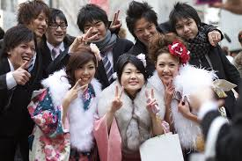 | 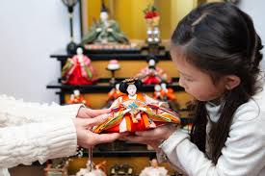 | It is …………………………………. for people to eat grilled eel in July and August to keep up their strength in the hot summer months.  People enjoy eating rice cakes while watching the full harvest moon. The moon’s shadows are thought to look like …………………………………. pounding rice.  Families …………………………………. beautiful dolls of a princess and her court to celebrate their daughters.  People wear …………………………………. clothes and join outdoor dances up and down Japan.  Picnics in the pleasant weather are enjoyed with friends, family or …………………………………. under the cherry blossoms.  Hardworking staff …………………………………. the stresses of the year with office drinking parties in December.  Children throw dried beans at a person wearing a devil …………………………………. to chase away both evil spirits and winter.  Families …………………………………. their children aged 7, 5 and 3 by visiting a shrine and treating them to long-life candy.  With comfortable weather, this is the perfect time for parents to enjoy watching their children perform dances and play …………………………………. sports at school.  Carp …………………………………. are hung from homes or over rivers to celebrate the strength of boys.  Since this is an important crop, …………………………………. are held to welcome the spirit of rice before while seedlings are planted in paddy fields.  Young people who will turn 20 in the coming year celebrate with a …………………………………. at their city hall and karaoke drinking parties into the night.
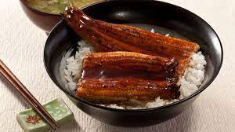 | 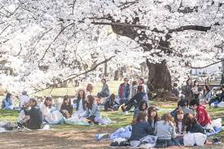
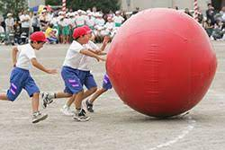 | 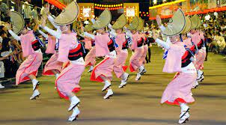
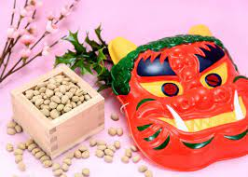 | 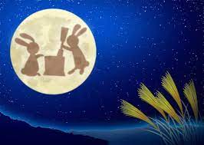
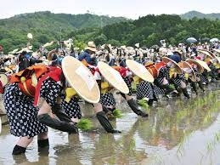 | 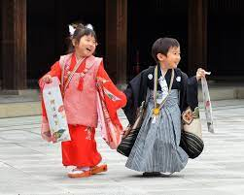
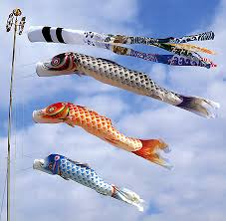 | 