Name………………………………………..date………………..………………………………………………………
- Draw and describe a “potato face” and a “carrot face.
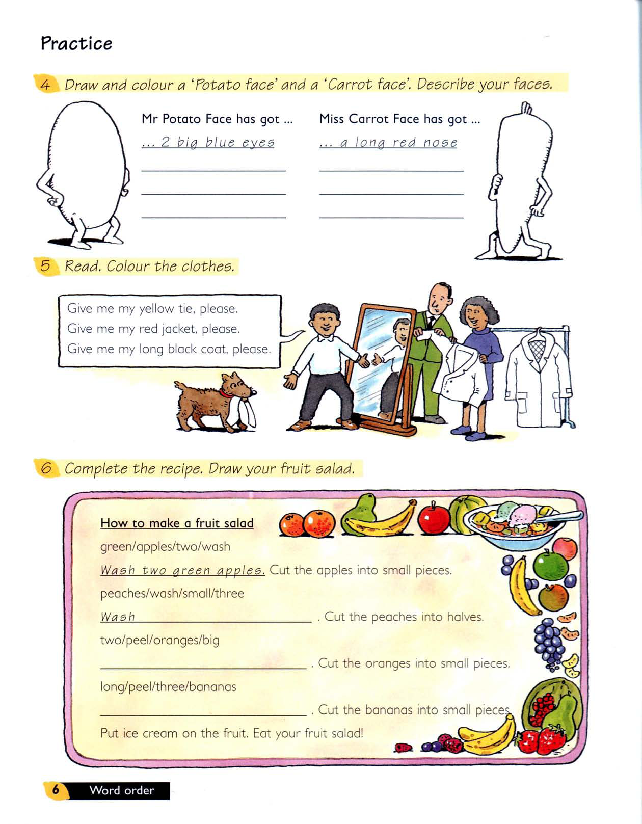
………………………………………………………………………………………………………………………………………………………………………………………………………………………………………………………………………………………………………………………………………………………………………………………………………………………………………………………………………………………………………………………………
Word bank; eyes
Mouth
Nose
chin
eyebrows
cheeks
teeth
tongue
hair
head

………………………………………………………………………………………………………………………………………………………………………………………………………………………………………………………………………………………………………………………………………………………………………………………………………………………………………………………………………………………………………………………………………………………………………………………………………………………………………………………………………………………………………..

- We are looking for a thief. He´s got a big nose and a small mouth. He´s got small ears and round eyes. He´s also got long curly hair and a moustache. Can you draw him?
WANTED

