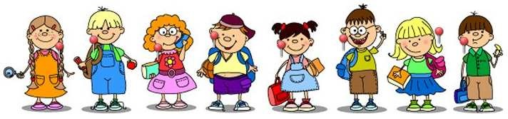
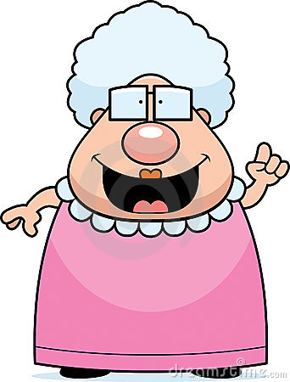

Look at the picture and use the words below to complete the gaps.
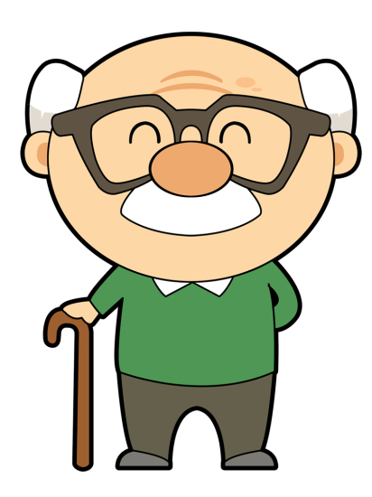
These are my grandparents. They are very sweet but ____________. Grandma Jane is 1,72 m tall. She is pretty ______________ for a lady. She weighs about 70 kg – she is a bit ______________. She has got ________________ hair. She has got a _____________ nose but ______________ ears. She has also got a big _____________. Her face is ________________.
Grandpa John is very different. He is ____________ and about 1,50m tall. So he is very ___________. His face is _______________ and he is ______________. He has also got a ________________. They both wear _____________.


Read the texts and complete the gaps with “to be” and “have got”. Use the negative form when necessary.
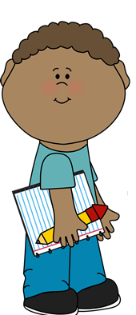
Linda and Mike ________ in my class. She ________ very cute but she ________ very tall. She ________ long plaited hair. She ________ some freckles too. Mike ________ short curly hair. He ________ fair skin. His skin ________ dark. He ________ tall.


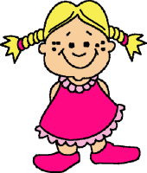


Tom and Cindy ________ my parents. My father ________ 40. His hair ________ long. It ________ short and straight. He ________ a very long nose. My mother ________ fair hair. It ________ medium length and wavy. Her mouth ________ big. Both my parents ________ small eyes.

This ________ Mr. Reynolds. He ________ my Math teacher. He teaches History. He ________ very friendly. He ________ a big moustache. His hair ________ short and brown. He ________ blue eyes. His eyes and nose ________ small, but quite big. His face ________ oval. He ________ a round face.

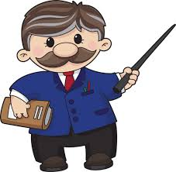

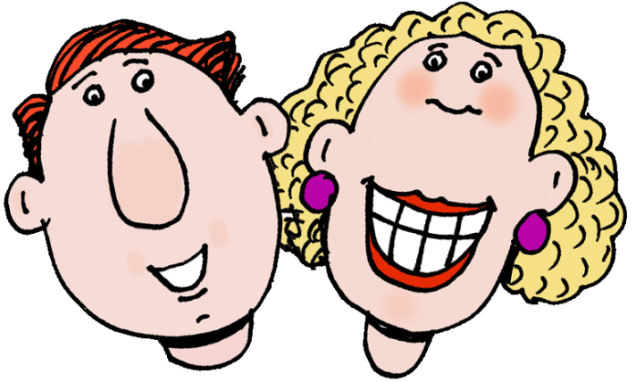

A.
These are my grandparents. They are very sweet but old.
Grandma Jane is 1,72 m tall. She is pretty tall for a lady. She weighs about 70 kg – she is a bit fat. She has got curly hair. She has got a big nose but small ears. She has also got a big smile. Her face is square.
Grandpa John is very different. He is slim and about 1,50m tall. So he is very short. His face is round and he is bald. He has also got a moustache. They both wear glasses.

B.
1. Tom and Cindy are my parents. My father is 40. His hair isn’t long. It is short and straight. He has got a very long nose. My mother has got fair hair. It is medium length and wavy. Her mouth is big. Both my parents have got small eyes.

2. Linda and Mike are in my class. She is very cute but she isn’t very tall. She has got long plaited hair. She has got some freckles too. Mike has got short curly hair. He hasn’t got fair skin. His skin is dark. He is tall.

3. This is Mr. Reynolds. He isn’t my Math teacher. He teaches History. He is very friendly. He has got a big moustache. His hair is short and brown. He hasn’t got blue eyes. His eyes and nose aren’t small, but quite big. His face isn’t oval. He has got a round face.

