ENGLISH FOR SENIORS – LESSON PLANS

Group: Seniors
Level: Beginner
Time: 45 minutes to one hour

Method: Saying a word or sentence in English them repeat in local language. Write on a whiteboard words and sentences and how they are pronounced. All of the students should repeat sentences out loud so they can learn how to pronounce words correctly.

Lesson 1

Objectives: Greetings, introduction, asking for one´s name, tell where one is from, ask where someone is from, asking: how are you, answering: how are you.

Course:
- Hello! Please, stand up and form a circle (repeat in local language or show with hands).
- Name game: A person says their name and makes a movement. The next person repeats their name and movement and tells their own name and adds a movement. It continues like that until everyone in the circle tells their name.
- Please, sit down (repeat in local language or show).
- My name is… (repeat in local language). What is your name (repeat in local language)? Everyone takes a turn asking and answering.
- I am from… (repeat in local language). Where are you from (repeat in local language)? Write on the whiteboard how their countries are called in English. Everyone takes a turn asking and answering.
- Write greetings on the whiteboard and repeat them in local language. Everyone should repeat them at loud. Greetings: Hello, hi, good morning, good afternoon, good evening, good night, good-bye, bye-bye.
- I am fine, well, very well, bad, quite well… (repeat in local language). How are you (repeat in local language)? Write possible answers on the whiteboard.

Materials:

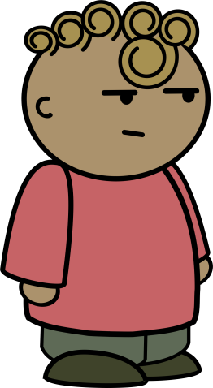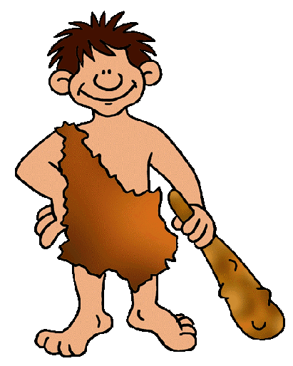
I am well, thank you.
My name is John. How are you?
My name is Michael. What is your name?
Hello! What is your name?

???

I am from the past! Goodbye!
Goodbye, Michael!
Where are you from?

Lesson 2

Objectives: to learn the alphabet and words thanks, thank you, you´re welcome, here you go/are, please, nice meeting you, you too.

Course:
- Hello! Please, stand up and form a circle.
- Name game: high five name toss. A person goes to someone, says their name and gives them a high five. They switch places. This continues until everyone´s name has been said. If there are not a lot of students it can be repeated multiple times.
- Please, sit down.
- Let´s repeat from the last lesson (repeat in local language). Everyone takes a turn repeating what they have learned on the previous lesson.
- Tell the students about the contracted version of I am, what is, name is.
- Alphabet. Give them the material with letters of the alphabet and their names (pronunciation).Go together through the whole alphabet. Everyone spells their first name.
- Homework (meeting).

Materials:

A (ej) 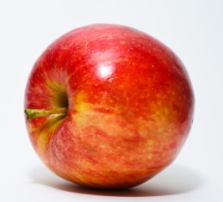 apple
B (bi) baloon
C (si) 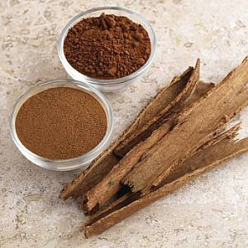 cinnamon
D (di)  diamond
E (i) 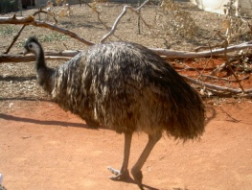 emu
F (ef)  foil
G (dži) 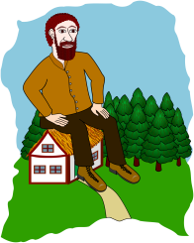 giant
H (ejdž) 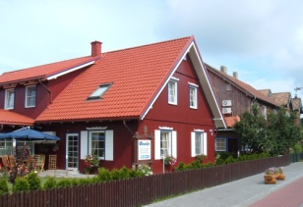 house
I (aj) 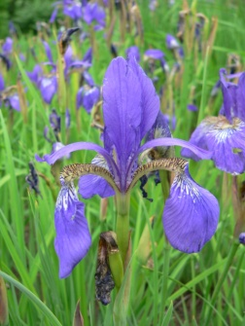 iris
J (džej) 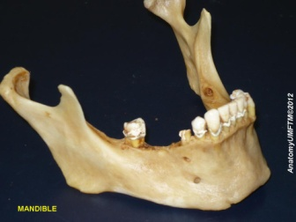 jaw
K (kej)  key
L (el)  lorry
M (em)  magnet
N (en)  newspaper
O (ou)  office
P (pi) 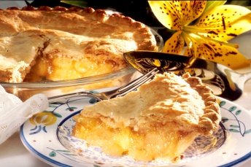 pie
Q (kju)  queue
R (ar) 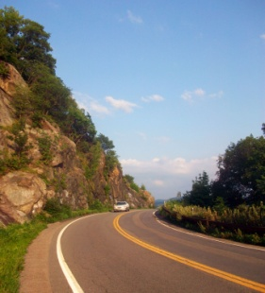 road
S (es)  sun
T (ti)  torch
U (ju)  utensils
V (vi)  virus
W (double ju) 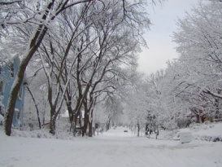 winter
X (eks) 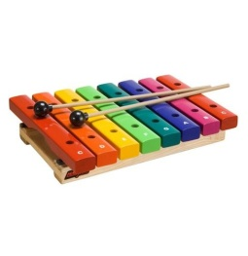 xylophone
Y (waj)  youth
Z (zet/zi)  zebra

Homework:

1. Hello! What is your ______?
2. _____! My name ____ Alice. What´s _____ name?
1. _____ name's Jane. ______ are you from?
2. _____ am from Slovakia. Where ____ you from?
1. I'm from Germany. _____ are you?
2. ____'m very well, thank you.
1. ____ meeting you. ______!
2. You ____. Bye-bye!

Lesson 3
Objectives: to learn the colours and some rules of pronunciation, start learning numbers.
Course:
- Hello! Let´s do some stretching (energizer).
- Please, sit down. Let´s repeat.
- Checking homework. Write the correct answers in the whiteboard and explain why something is incorrect if they have any mistakes.
- Write down names of the colours (repeat in local language).
- Rules of pronunciation:
  - C followed by E, I, Y = sound S: central, city, cyst
  - C followed by A, O, U = sound K: can, cow, currency
  - G followed by E,I,Y = sound Dž: gem, gym, gist
  - G followed by A, O, U = sound G: gay, go, guy
- Write cardinal numbers on the board.
- Tell them about alphabet and number songs on YouTube.
Lesson 4
Objectives: Learn numbers to 1000, to tell and ask someone´s age, words first name, last name, surname.
Course:
- Hello! Please, stand up and form a circle.
- Bananas of the world unite! (energizer) Show them the movements for the song. They should repeat after you. Do it a few times.
- Let´s repeat! Repeat everything they´ve learned so far in a way that everyone participates. Count to the last number you´ve taught them.
- Please, spell your first and last name (repeat in local language). Everyone should spell it.
- Continue with teaching them the numbers.
- I´m… years old (repeat in local language). How old are you (repeat in local language)? Everyone should tell their age.
- How much is x plus/minus y (repeat in local language)? It is… (repeat in local language)
- Home work (introduction, colours and numbers).
Homework:
1 Fill in the missing words
1. Hello! ______ is your name?
2. _____! My name _____ Jenny.
1. _____ are you from?
2. _____ˈm from United Kingdom. What _______________ name?
1. My _____ˈs Anne. I’m _____ Russia.
2. How old _____ you, Anne?
1. Iˈm ___________________ (31) years ______. How old ________________?
2. I am ___________________ (42) ________ old. How are you?
1. Iˈm ______ well, _______ you. And how are _______?
2. I am O.K. ________ meeting you. Goodbye!
1. You ______. Bye-bye!

2 Write down the numbers
42 ___________________________
51 ___________________________
18 ___________________________
9 ____________________________
0 ____________________________
100 __________________________
55 ___________________________
98 ___________________________
13 ___________________________
5 ____________________________
2 ____________________________

3 Fill in the missing words

1. I am (20) _________________ years old.
2. Are you (51) _________________ years old?
3. I have (10) __________________ apples.
4. How old are you? I’m (63) _______________.
5. I have (3) ______________ sons.

4 How much is it?
1. One + three = __________
2. Two + two = __________
3. Four + six = __________
4. Seven + one = __________
5. Three + two = __________
6. Five + four = ___________
7. Fourteen + three = __________
8. Nine + four = _________
9. Seventeen – six = __________
10. Fifteen - three = __________
11. Eight + eight = __________
12. Twenty – five = __________

5 Fill in the missing words
1. I´______ _____________ (20) years old.
2. How old _________ you?
3. He ______ British.
4. Where ______ she from?
5. They ______ from Germany.
6. She’____ ________________ (51) years old.
7. There is a tree. It ______ tall.
8. There is my friend. -How old _____ he?
9. We’_____ students.
10. You ______ very good friends.

6 What colour is this?

___________________
___________________
____________________
____________________
____________________
____________________
____________________
_____________________
_____________________
_____________________

