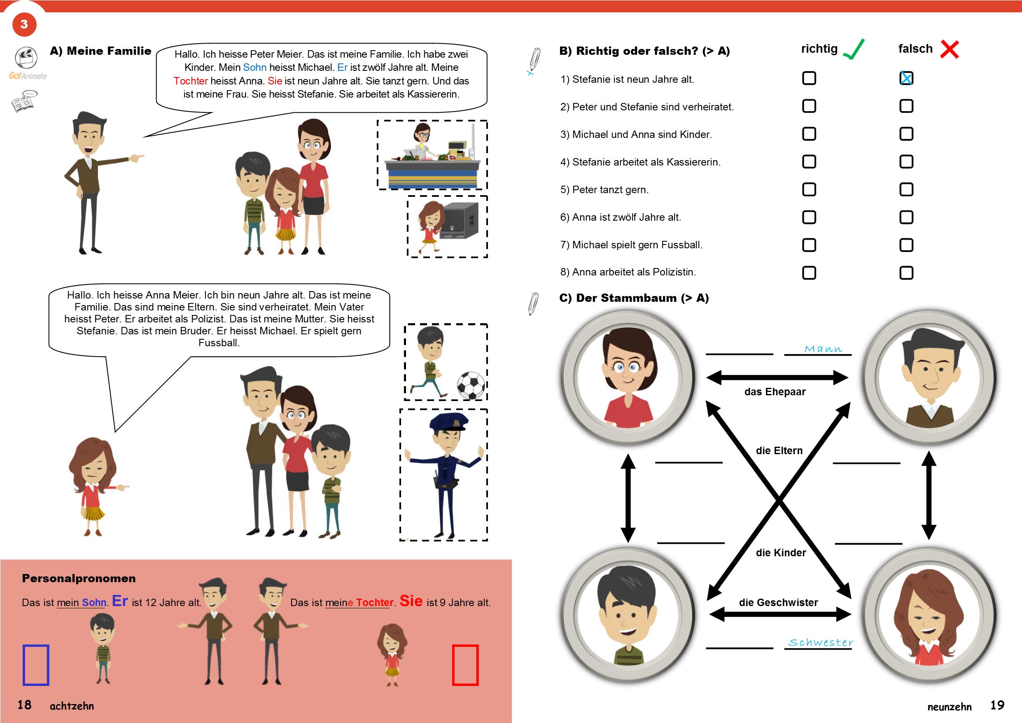
https://www.youtube.com/watch?v=2yZkGI-8yCY

