Put the QR-codes in different places in the classroom or in the yard – if the weather permits – and tell the students to scan the qr-codes to find out what the different tasks are. Give them the top part of this page and tell them to write the answers down.
Answer for #15
_______________
_______________

Answer for #14
_______________
_______________

Answer for #13
_______________
_______________

Answer for #12
_______________
_______________

Answer for #11
_______________
_______________

Answer for #10
_______________
_______________

Answer for #9
_______________
_______________

Answer for #8
_______________
_______________

Answer for #7
_______________
_______________

Answer for #6
_______________
_______________

Answer for #5
_______________
_______________

Answer for #4
_______________
_______________

Answer for #3
_______________
_______________

Answer for #2
_______________
_______________

Answer for #1
_______________
_______________








3
2
1



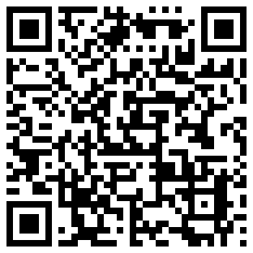


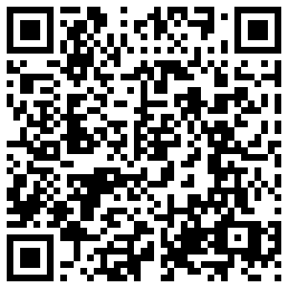






15
14
13
12
11
7
10
9
8
6
5
4

