Circle the correct answer:
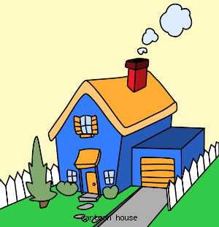
1.
T / F 1. The house is blue with a yellow roof.
T / F 2. The grarage is on the left side of the house.
T / F 3. There is a grey fence around the house.

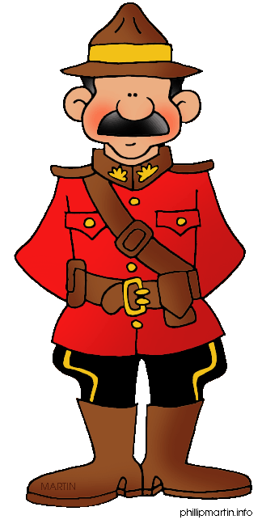
2.
T / F 1. The woman is wearing a uniform.
T / F 2. The man has a black moustache.
T / F 3. He wears a hat and a leather belt.

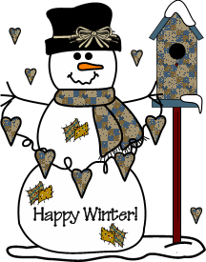
3.
T / F 1. This guy can only be seen when it is very cold and snowy.
T / F 2. The snowman wears a scarf and gloves.
T / F 3. The snowman is next to a bird house.

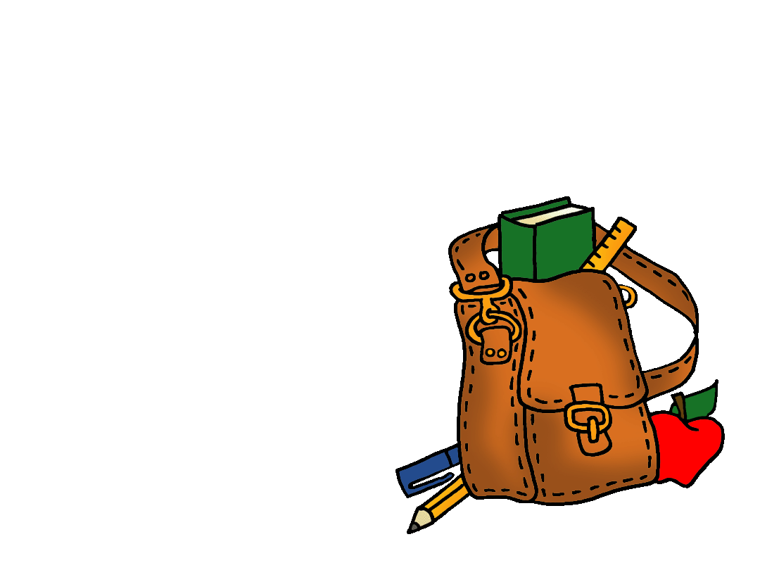
T / F 1. Here is my blue school bag.
T / F 2. There is a green book, a yellow ruler and a red apple in it.
T / F 3. It says: “I love school” on it.
4.

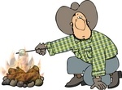
5.
T / F 1. Joe the cowboy is cooking sausages on the fire.
T / F 2. Jos’ cowboy hat is grey with a black ribbon.
T / F 3. There is a marshmallow on a stick over the fire.

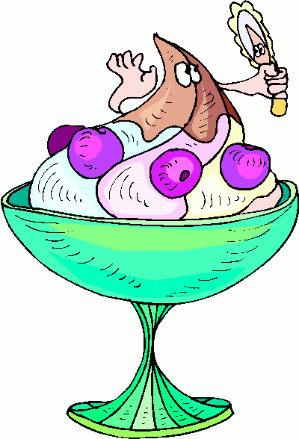
6.
T / F 1. Here is a nice dessert with bananas and blue berries.
T / F 2. The glass has a mint green color.
T / F 3. A yummy dessert with blue berries, ice cream and chocolate.

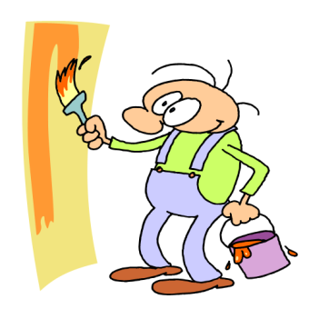
7.
T / F 1. John is a painter and he is painting a wall in his home.
T / F 2. John likes green so all his clothes are green.
T / F 3. John has to be careful. The painting is dripping from the bucket.

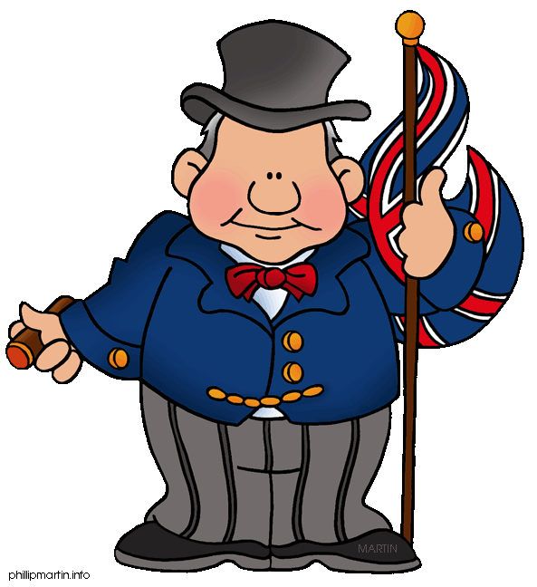
8.
T / F 1. This guy is from Great Britain.
T / F 2. He wears an old and ugly uniform.
T / F 3. The hat and the butterfly are both red.

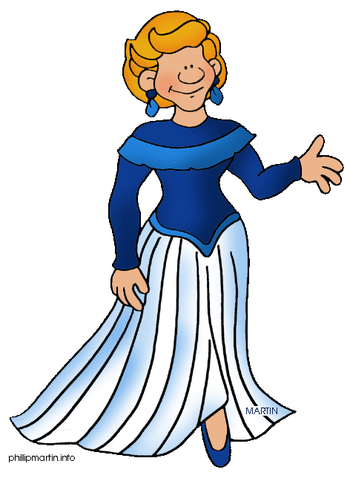
9.
T / F 1. The lady is wearing an elegant dress.
T / F 2. Her ear rings are purple.
T / F 3. She has got wavy hair.

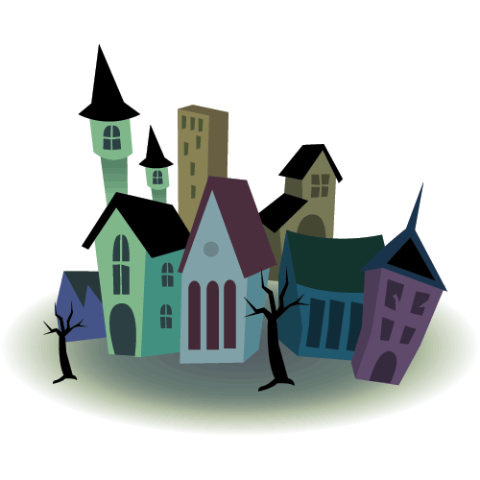
T / F 1. The picture shows a small village.
T / F 2. There are ten buildings in this village.
T / F 3. Two houses are red with blue stripes.
10.

