The Songkran Festival

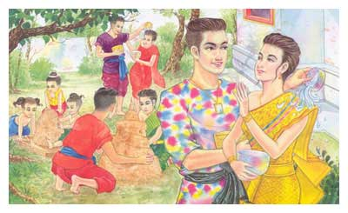
(Source: http://www.relaxzy.com/place/songkran.html)

The songkran or Water Festival is the traditional Thai New Year’s celebration. Generally, it is held for a period of 3 days, from April 13 to 15 - the hottest time of the year. The word “Songkran” is from Sanskrit, meaning the beginning of a new solar year. In the traditional Thai calendar, this falls in April, when the sun enters Aries. Thus, the Songkran Festival is held to mark the beginning of a new solar year.
Songkran is celebrated all over Thailand, especially in the northern province of Chiang Mai and at Paklat, a riverside area of Pra Pradaeng in Samut Prakarn Province, where the occasion is celebrated to the fullest and processions are exceptionally colorful and joyful. Songkran is celebrated not only in Thailand, but also in neighboring countries, such as Myanmar, Laos and Cambodia.

Exercise 1
Answer the following questions.

1. What is the Songkran Festival? __________________________________________
2. When is it celebrated and how long does it last? _____________________________
3. What does “SongKran” mean? ___________________________________________
4. Why is the Songkran Festival celebrated? __________________________________
5. Where is the Songkran Festival celebrated? _________________________________

