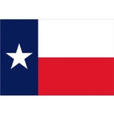
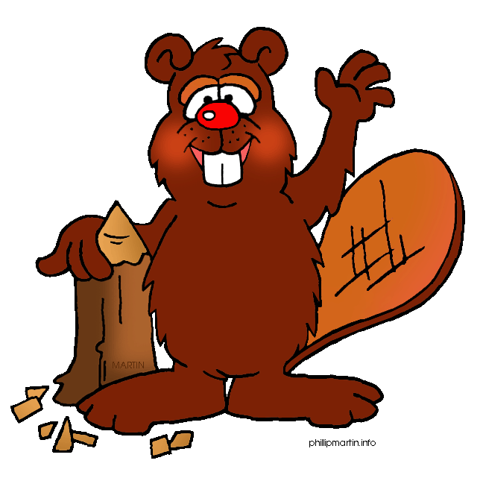
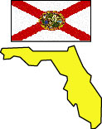
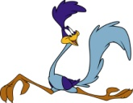
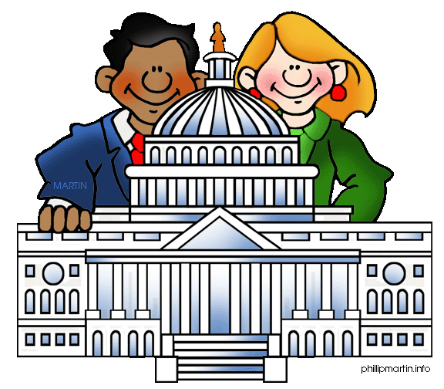
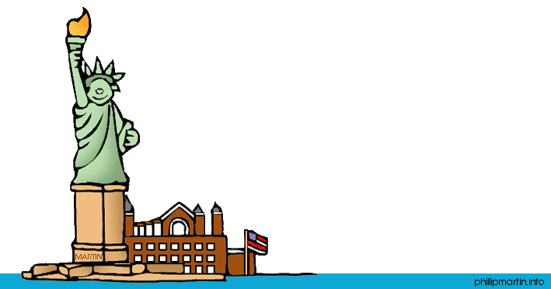
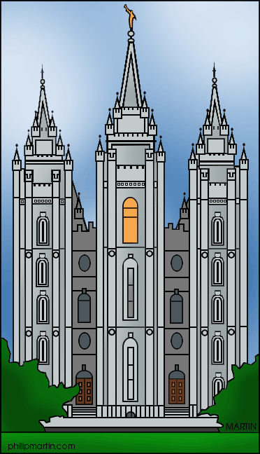
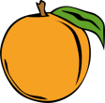
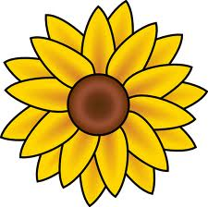
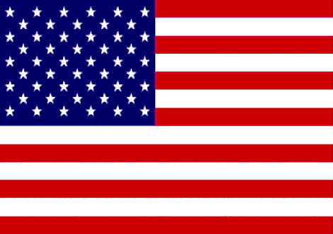


Which is the smallest state by area?
Capitol is situated in which state?
Which four states can you stand in at the same time?

Which state?
Three states spell their name with four letters. Which?

Las Vegas is a famous city in which state?
Which state is known for growing oranges?
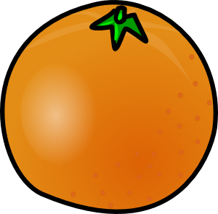

Which state has the longest name (oficially)?
94% of Yellowstone National Park lies in this state!
What state entered the constitution as number 50?

Where do you find “The White House”?

Which state is also called the “Grand Canyon State”?

Kansas is known for this flower.
Which state is known as ”The Lone Star State?

This state is known for its shellfish and lobsters.
Where do you find ”The Statue of Liberty”?

Which state is the largest?
This state is also known as “The Last Frontier”.

Which state’s name means “Great Water”?
Which state is home to the Great Salt Lake?
This state boasts to have the best potatoes!

Which state is ”The Peach State”?

Which states is known as “The Golden State”?

Where do you find Mount Rushmore?
Roadrunner! State bird where?

Honolulu is the capital city of this state!

You get an extra throw!
How many states make up the USA?

Known as the Beaver State!

Mention three states starting with an “M”.
Which state was known to be “the First State”?
The famous Tabernacle is from..?

