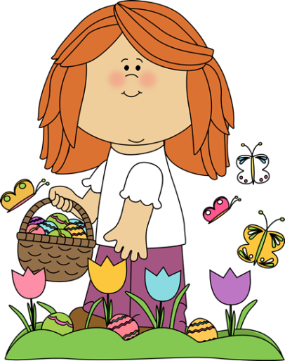
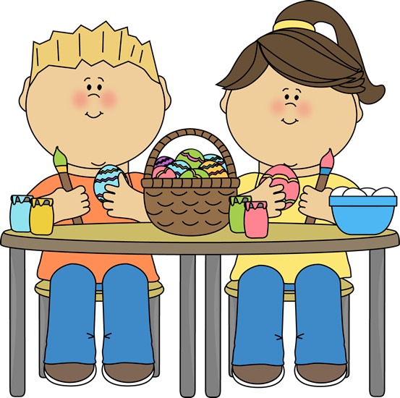

Do you think Easter has the same importance today as it had some years ago?
Why/ why not?

Do you consider Easter an important holiday?
Why/ Why not?

What are the 40 days before Easter called?

Do you have any special family celebrations?

What is the Sunday before Easter called?
What is the Friday before Easter called?

Do you know the meaning of Easter? –and why we celebrate it?

Why do we celebrate Easter?

How do you celebrate Easter in your country?
Instructions:
1. Cut the cards out and laminate them if you want them to last longer.
2. Pair students in twos.
3. Give them some cards and have them walk from one point to another. One leg = one card.

