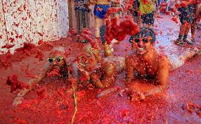
Tomatina (Spain)

This festival takes place once a year in August in Buñol, Spain. In this wild tomato fight tons of overripe fruit are tipped into the streets and used by locals and thousands of tourists as ammunition. Tomatina has no religious or political background; the festival was invented just for fun.

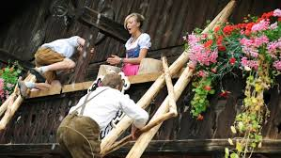

Window climbing (Austria)

45 young men venture on a breakneck course the facade of a house up to kiss a pretty girl on the balcony. This competition is held in Zillertal and attracts many tourists.

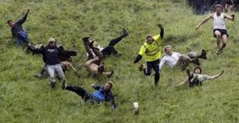
Cheese Rolling Competition (England)

The "Cheese Rolling Competition", which has been going on for many years in May in Gloucestershire, England, is not without its dangers. The approximately three-pound loaf of Gloucester cheese is rolled down the hill and reaches speeds of up to 110 kilometers per hour. It's practically impossible to catch up with it, so the fastest man and the fastest woman win.

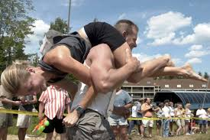
Wife carrying competition (Finland)

The Wife Carrying World Championship has been held annually in Sonkajärvi, Finland, since 1992. It is a contest in which male competitors race while carrying a female teammate. The objective is for the male to carry the female through a special obstacle track in the fastest time.
The prize is the wife's weight in beer
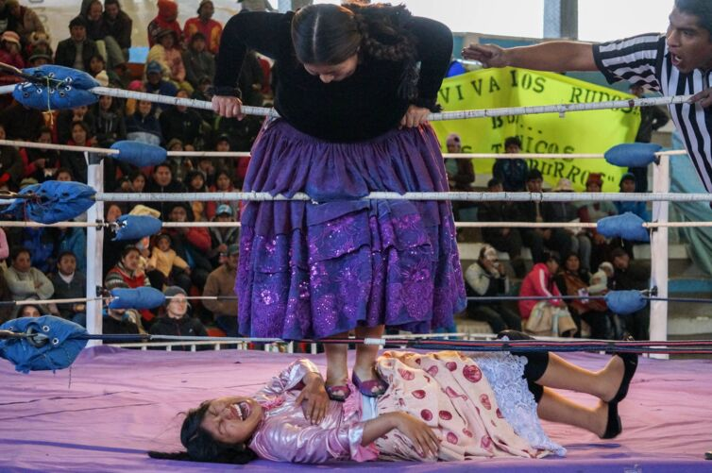
Cholita-Wrestling (Bolivia)

Wrestling, but this time with a lot more clothes: in Bolivia, Cholitas - indigenous women - fight each other. They wear their traditional clothing, which consists of up to ten petticoats, a shawl and a hat.

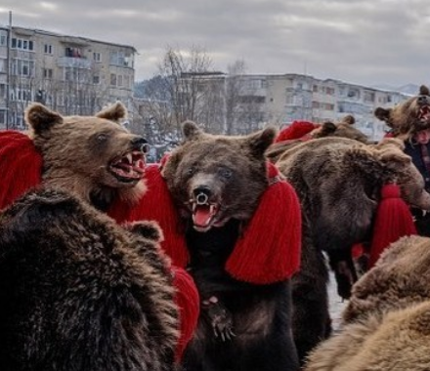

Bear Dance (Romania)

Every year, between Christmas and New Year's Eve, in the historic region of Moldova in Romania, adults and children dress up as bears and dance in the streets. This looks a bit scary, because people actually wear real bear furs.
The ritual is intended to drive out evil spirits.

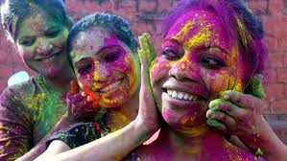
Holi (India)

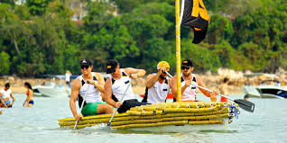
A veritable explosion of colors is the Hindu Holi festival, which heralds the beginning of spring. And with a true rush of color, which is distributed to everyone. On this single day of the year, when caste, religion, age or gender are irrelevant, brightly colored paint powder is poured over everyone who comes along the way. Not to forget the religious background: While the color splendor stands for fertility and a new beginning, the mutual throwing with the colors should stand for a leveling of all differences.

Beer cans Regatta (Australia)

Australia is at the other end of the world. Even there they like to drink beer.
But where to go with the many empty beer cans? In Darwin in the north of Australia, the annual beer can regatta offers an imaginative and, above all, fun solution. Because here self-built boats from empty beer cans compete against each other.

Which festival is meant?

1. Only women participate in the competition .......................................... ..........................................
2. It is very colorful .............................................................................................. ..............................
3. The men must be strong ........................................... ....................................................................
4. The winner may kiss the woman ....................................................................................................
5. It is very dangerous ........................................................................................................................
6. This competition takes place on the water .....................................................................................
7. People are getting really dirty .........................................................................................................
8. The men have to climb ...................................................................................................................
9. This activity shall drive away the evil spirits ...................................................................................
10. You need a cheese for this competition .......................................................................................
11. A lot of beer has to be drunk before the festival ...........................................................................
12. Children and adults participate in this festival ........................................ .....................................
13. Vegetables are used as ammunition ............................................................................................
14. There are forty-five participants ....................................................................................................
15. There are no social differences on this day ..................................................................................

Answer the questions

1. Do you like this kind of festival? Why? Why not?
............................................................................................................................................................
2. Have you ever attended such a festival? Which?
.................................................. .........................................................................................................
3. Which of these festivals would you like to attend? Why?
.................................................. .........................................................................................................
4. Which of these festivals would you never participate in? Why?
.................................................. .........................................................................................................

Tell about a festival in your country

