1SHE

2 THEY
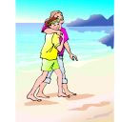
3 I

4 WE

5 SHE
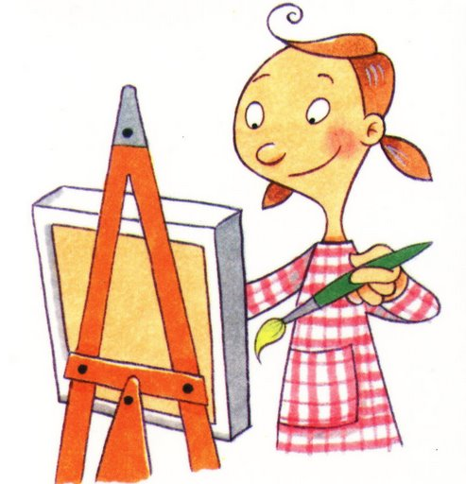
6 LEO

7 BEN

8 YOU

9 THEY
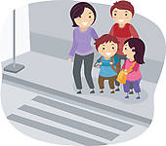

10 FRANK


11 I

12 PETER

13 WE

14 I


15 HE
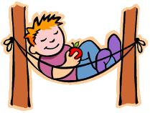
16 I
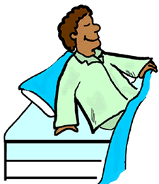
17 SHE

18 MY SON
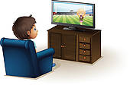
19 I
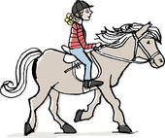
20 HE

21 THEY


22 DAD
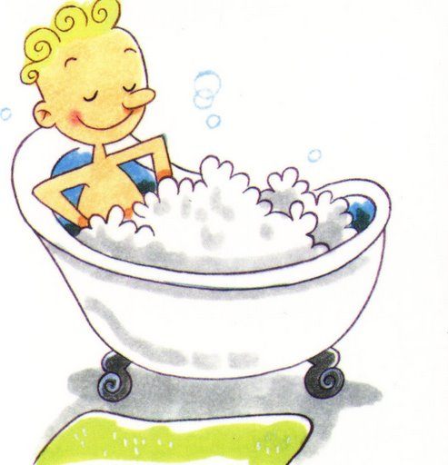
23 MUM

24 YOU
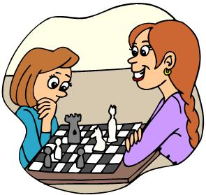

25 WE
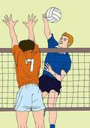

26 CARL
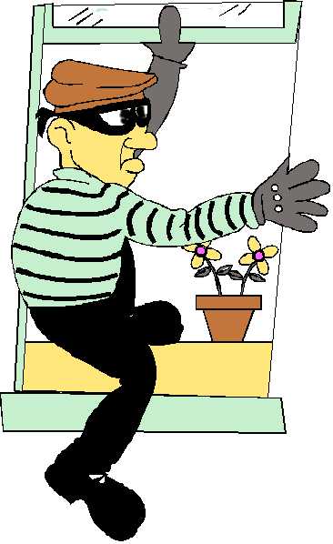
27 HE

28 LEO

29 THE PAINTER
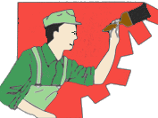
30

HOME

ANSWERS
These are sample sentences. Other answers are possible.

1 She is going to take the bus because she wants to go to the city center.
2 They are going to walk on the beach because it’s a sunny day.
3 I’m going to go to a pet shop because I want to buy a dog.
4 We are going to dance because we are at a disco.
5 She is going to paint a picture to give it to her mother for mother’s day.
6 Leo is going to eat pizza because he is very hungry.
7 Ben is going to give his girlfriend flowers because he loves her.
8You are going to close the door because it is very cold.
9 They are going to cross the street because they want to go to the park.
10 Frank is going to greet his friend he has just met.
11
I’m going to iron my dress because I have a party tonight.
12 Peter is going to water the plant because it is dry.
13 We are going to read the newspaper because we want to be well informed.
14 I’m going to think about the problem which is hard to solve.
15 He is going to relax because he is lazy.
16 I’m going to sleep early because I’m tired.
17 She is going to work late because she has to finish something.

18 My son is going to watch TV because he wants to see a documentary.
19 I’m going to ride my horse because I have to train it.
20 He is going to call his friend to invite him to his party.
21 They are going to wash the car because it is dirty.
22 Dad is going to have a bubble bath because he wants to relax.
23 Mum is going to dry her hair because it is wet.
24 You are going to play chess because you are in a chess club.
25 We are going to play volley ball because we are in a competition.
26 Carl is going to enter the house because he is a burglar.
27 He is going to deliver the letters because he is a postman.
28 Leo is going to make a film because his TV channel asked him to.
29 The painter is going to paint the walls of my room because they are dirty.
30 They are going to dive because they want to see the see life.
HOME

Instructions for the teacher.

Preparation
- Print the board games on tick paper or a cardboard; laminate them if you want to use them many times.
- Find tokens for each student.
- Provide dice.
- Divide the class into groups of 3 – 4 students each.
- Give each group a board game and a die.
- Give each student a token (or bean, coin, button, etc.).

The game
- The players put their tokens on the square Number 1.
- The first student throws the die and moves his token ahead the corresponding number of squares.
- The student says what the people are going to do according to the pictures and the indicated person. More advanced students could give a reason for their actions.
- Example: She is going to take the bus because she has to go to the city center.
- If the answer is correct, the student stays, if the answer is incorrect, he has to go back where he came from.
- The first student who takes a number that places his token on “home” or surpasses it is the winner.

