2020-2021 EĞİTİM ÖĞRETİM YILI ORTAOKULU
8.SINIFLAR 1.DÖNEM 1.YAZILISI
NAME SURNAME : NO : GRADE : 8 / …

A) Complete the dialogues with the sentences below. (4 x 5 = 20p)
I’d love to but I can’t How about watching a movie
No, not at all I am stuffed
Drake : ______________________________ ?
Betty : That sounds awesome. What about a thriller?
Merlin : Would you like to go to the theatre on Sunday?
John : ______________________________ . I’m going to visit my cousin on that day.
Tina : Do you want a hamburger?
Lilly : No, thanks. ______________________________.
Helen : Are you busy tomorrow morning?
Gail : ______________________________ . Why?

B) Complete the table with adjectives below. (6 x 2 = 12p)
Honest Snob Generous
Reliable Stubborn Selfish


GOOD FRIENDS BAD FRIENDS
- _________________
- _________________
- _________________
- _________________
- _________________
- _________________
- _________________
- _________________

C) Match the words with the definitions. ( 5 x 2 = 10p)
a) fashionable or attractive ( … ) 1. honest
b) relaxed in manner and character ( … ) 2. stuffed
c) someone always telling the truth ( … ) 3. cool
d) not hungry ( … ) 4. argue
e) to discuss on a topic ( … ) 5. laid-back
D) Add 4 more types of movie to the list below. ( 4 x 2 = 8p)
Types of Movie
- Animation - Western
- _______________ - _______________
- _______________ - _______________




E) Find and correct the mistakes in the sentences below. (5 x 5 = 25p)

1) Why don’t we going hiking?
_____________________________________________
2) I prefer playing football with seeing a movie.
_____________________________________________
3) She doesn’t likes spending time with her friends.
_____________________________________________
4) Would you like to joining us?
_____________________________________________
5) How about go skating tomorrow?
_____________________________________________

F) Read the mail below.
Dear Helen,
Thanks for inviting me to your birthday party. I’d love to attend your party, but I have a science project and I have to finish it until Sunday. I will give your present after your birthday. I am sure you will like it.
Love,
Rebecca.

1. Are these sentences T (True) or F (False)? Circle. (5 x 3 = 15p)
1. Rebecca doesn’t want to join the party. T / F 4. Helen wants Rebecca to join her birthday party. T / F
2. Rebecca will join Helen’s party. T / F 5. Rebecca has a reason to refuse Helen’s invitation. T / F
3. Helen is the receiver of the mail above. T / F
G) Solve the puzzle. (5 x 2 = 10p)
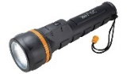

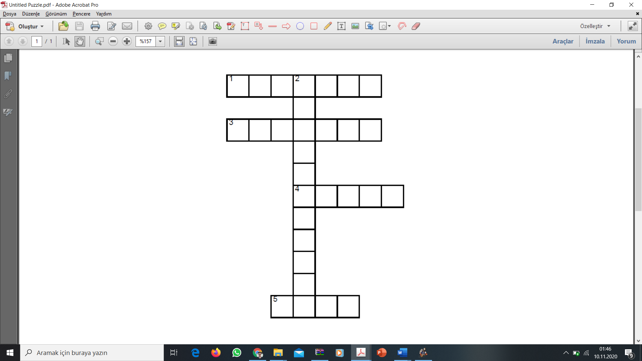





www.eegitimim.com

