4.Sınıf İngilizce Test 1

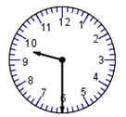**1.**  **What time is it? (9:30)**

a)It’s three fifteen. b)It’s half past thirty. nine

c) It’s ten thirty. d) It’s six thirty.

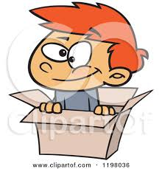**2.**

**A: Where is the boy?**

**B: He is …….. the box**.

a) in b) behind c) between d) under

**3. He is a ................. .** 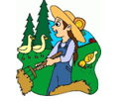

**A)** farmer  **B)** dancer   
**C)** chef  **D)** teacher

**4.I’m a ................. . I work at a school.**

**A)** doctor **B)** policeman   **C)** teacher      **D)** farmer

**5. Which season is it?**  
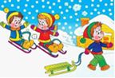  
  
**A)** winter  **B)** spring   
**C)** summer **D)** autumn

**6.**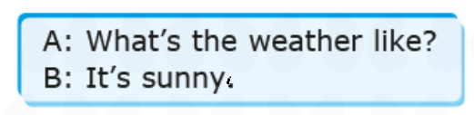

a) 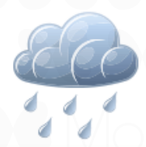b) c) 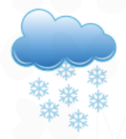d) 

**7.** **What’s the weather like?**

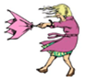

**a)** It’s hot. **b)** It’s windy.

**c)** It’s sunny. **d)** It’s snowy.

**8. Wear your ………………**

  
**A)** trousers  **B)** sunglasses **C)** skirt  **D)** gloves

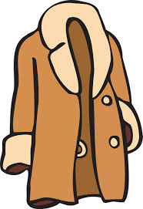9. . A: What’s that?  
 B: It’s a …………………….

a) dress b) sweater c) coat d) shirt

**10.** 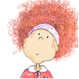

I have ______ hair

**a)** long **b)** straight **c)** blonde **d)** curly

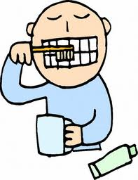**11. What do you do at 8 o’clock?**

**a)** I wash my face.

**b)** I brush my teeth.

**c)** I have breakfast.

**d)** I go to school.

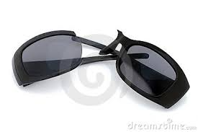**12.**  **May I borrow your sunglasses? ☹**

A) Yes you may.

B) Sure.

C) I’m sorry. It’s broken

D) Yes, of course.

**13. What do you like?**   


A) I am a farmer.  B) I like animals.

C) I work on the farm. D) She is a student

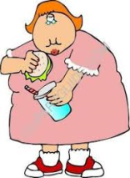**14 . What does she look like ?**   
  
**A)** She is energetic.  
**B)** She is slim and tall.   
**C)** She is heavy (fat).  
**D)** She is hardworking.

**15-DENIz: What is he like ?**

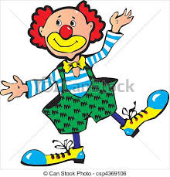

**TAMER: ………………………….**

**A)**He is funny.

**B)** He is shy.

**C)** He is tall

. **D)** He has short hair.

**16. Melis:** What is Ali like?

**Sema:______________**

**a)** He is tall and thin.

**b)** He is polite.

**c)** He has green eyes.

**d)** He has brown hair.

**17.** He is……………………

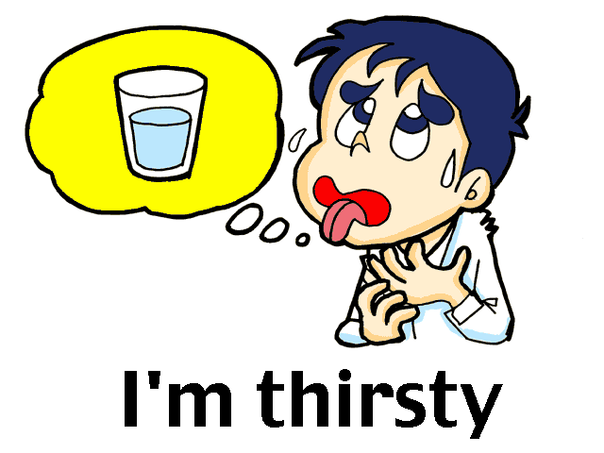

A) thirsty B) hungry C) rude D) slim



**18-I am …………and I want some chicken.**

a)thirsty b) hungry c )full d) tall

**19. A:What is your favourite food?**

**B:My favourite food is ______.**

a) fish b)hamburger c) chicken d)sandwich

j0199941**20-What is your favorite drink** ?

1. Tea
2. Apple juice
3. Ayran
4. Water