2014 – 2015 EDUCATION YEAR
FATİN RÜŞTÜ ZORLU SECONDARY SCHOOL 5TH GRADE FIRST TERM SECOND ENGLISH EXAM
Name:
Surname:
Class:
Number:
A) Match questions and answers . ( soruları ve cevapları eşleştiriniz.) (5*4 p)
1. What is your name ? a.I am from Turkey.
2. How old are you? b.I am 12 years old.
3. Where are you from? c.I am a student.
4.What is your nationality? d.I am turkish .
5.What are you doing? e.My name is Alara.

B) Write turkish meanins of daily activities( Günlük aktivitelerin türkçe anlamlarını yazınız.)(6*3p)

Go to school:..................................................... Do homework:..................................................
Get up:............................................................... Go to :................................................................
Have breakfast :........................................... Have dinner:.....................................................

C) Match countries wıth the nationalities.( Ülkeleri milliyetlerle eşleştiriniz.)(7*3p)
1. Italy a)Turkish
2. Turkey b)French
3. Germany c)Italian
4. Spain d)English
5. England e)German
6. The USA f) Spanish
7. France e)American

D) Write our city, our region,our country and our capital .( Bölgemizi,şehrimizi,ülkemizi ve başkentimizi yazınız.) (16 p)
Our city:
Our region:
Our country :
Our capital:

E) Look at the clocks and complete the sentences .( Saatlerle Cümleleri eşleştiriniz.)(5*5 p)

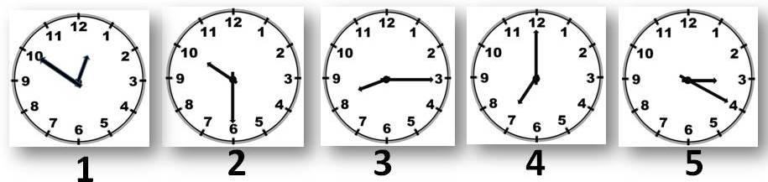

half | past | o’clock | to | quarter

- It is ten ……... one.
- It is ………….. past ten.
- It is ……………. past eight.
- It is seven ….………………… .
- It is twenty ….………….. three.

GOOD LUCK

