2019-2020 EDUCATIONAL YEAR GAFARLI TAŞKÖPRÜ SECONDARY SCHOOL
1ST TERM 2ND ENGLISH EXAM FOR 5TH GRADES

NAME - SURNAME: NUMBER - CLASS:

- VOCABULARY PART
- Match the words with the correct pictures. Choose from the list.(20 POINTS)
(Sing a song) – (Skip rope) – (Rollerskate) – (Hide and seek) – (Do magic) – (Play yoyo)(Keepy uppy) – (Hopscotch) – (Dodgeball) – (Blind man’s buff)

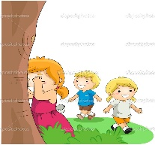 | 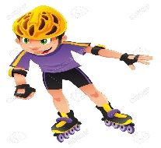 |  | 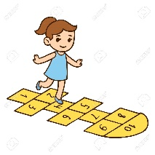
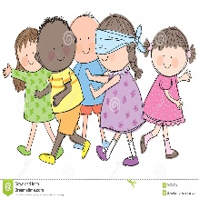 |  | 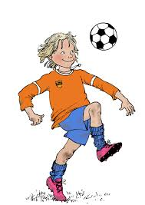

B) Read and complete the sentences. Choose from the list.(10 POINTS)
(goes - feeds) – (start - finish) – (brush - comb) – (have - do) – (gets on - arrives)
1)I ______________________ my teeth and _______________________ my hair in the mornings.
2)My sister _________________ the school bus and she __________________ at school at 08:30.
3)My brother ____________________ online and __________________ his dog in the afternoon.
4)I ______________________ dinner and ____________________ my homework in the evening.
5)My classes ___________________ at 08:20 and ____________________ at 14:55 on weekdays.
2) COMPREHENSION PART
- Match the questions with their answers.(10 POINTS)
 | 1)Where is Carol from? | a)Turn right into AtatürkStreet. It is on your left.
 | 2)How many languagesdo you speak? | b) At half past six.
 | 3)Where is the grocery? | c)I play games and listen to music.
 | 4)Excuse me, how can I get to Taksim? | d) He likes playing Chinese Whispers.
 | 5)Can you play a musical instrument? | e) No, I don’t.
 | 6)What is Ali's favourite activity? | f) Two. Turkish and English.
 | 7)Do you like playing video games? | g) By school bus.
 | 8)What time you get up in the morning? | h)She is from the USA.
 | 9)What do you do after school? | i)It’s between the bakery and the cafe.
 | 10)How do you go to school? | j) Yes, I can play the guitar.

B) Match the clocks with the time.(10 POINTS)
 | 1) 08:00 | a) It’s quarter past ten.
 | 2) 10:15 | b) It’s half past five.
 | 3) 05:30 | c) It’s eight o’clock.
 | 4) 10:45 | d) It’s ten past nine.
 | 5) 09:10 | e) It’s quarter to eleven.

C) Read the paragraph and tick (✔) the children’s likes.(10 POINTS)
ACTIVITIES | NAMES | ARDA | MERVE | BUSE
Hiking
Taking photos
Swimming
Playing dodgeball
Playing basketball
Playing chess

Hello! I’m Arda and these are Merve and Buse. We are good friends, but we like doing different things. Merve and I like hiking and taking photos, but Buse doesn’t. She enjoys swimming. Merve and Buse love playing dodgeball, but my favourite game is basketball. I also like playing chess.
3) WRITING PART
A)Look at the table and write sentences as in the example.(10 POINTS)
NAMES | CAN | CAN’T
EBRU | dance | sing songs
ALİM | do origami | do magic
CANAN | skip rope | rollerblade
METEHAN | do puzzle | play checkers
BEYZA | play chess | play tag

Example: Ebru can dance, but she can’t sing songs.
1) _______________________________________________________________________
2) _______________________________________________________________________
3) _______________________________________________________________________
4) _______________________________________________________________________
4) READING PART
Hello!
I am Kevser. I am a student in the 5th grade. Every day, I get up at seven o’clock and wash my face. I have breakfast at quarter past seven. After breakfast, I brush my teeth. I get dressed and get on the school bus at quarter to eight. My classes start at half past eight. I have lunch at quarter past twelve at the school canteen. I come back home at quarter past three. I do my homework and watch TV. My family and I have dinner at six o’clock every evening. I read a book after dinner and go to bed at half past nine.
A) Read the text and circle “True” or “False”.(15 POINTS)
1)Kevser has breakfast at 07:15 in the morning. | a) True | b) False
2)Kevser goes to school by train. | a) True | b) False
3)Kevser has lunch with her family at home. | a) True | b) False
4)Kevser does homework and watches TV after school. | a) True | b) False
5)Kevser goes to bed at 09:15 p.m. | a) True | b) False
5) LISTENING PART
A) Listen to the children and complete the text with the expressions below.(15 POINTS)
(Hide and seek) – (fishing) – (hopscotch) – (camping) – (skipping rope)
HARRY | Hello! I’m Harry from Denmark. I’m fourteen. I go to the park with my friends on weekends. We play soccer and marbles. I love playing marbles, but I don’t like playing _________________________.
LISA | Hi! This is Lisa from Britain. I’m thirteen. I play with my friends after school. ______________________________ is my favourite. But I don’t enjoy playing Chinese whispers.
MARK | Hi! My name is Mark. I’m from Germany. I’m fifteen. I usually go ____________________with my dad on Fridays and I love it. I also play dodgeball with my friends and it is fun. But I don’t like_____________________________________.
BESTE | Hello! I am Beste. I am from Türkiye. I am twelve. I play blind man’s buff and I am crazy about it. I like ____________________, but I dislike riding a horse.

TEACHER OF ENGLISH
GOOD LUCK
“Yalnız bir şeye ihtiyacımız vardır; ÇALIŞKAN OLMAK..” (MUSTAFA KEMAL ATATÜRK)

