……………………………………………. 5.SINIFLAR 2.DÖNEM 1.İNGİLİZCE YAZILISI
Name: Number: Class: ……………
A)Tablodaki hastalık isimleri resimlerin altına yerleştiriniz.(7X3=21)
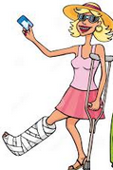
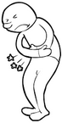
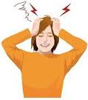
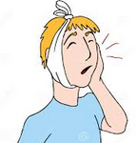
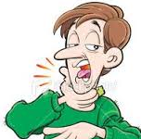
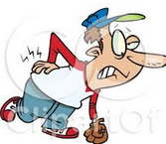
headache --- flu --- sorethroat -- backache--broken leg -- toothache --- stomachache
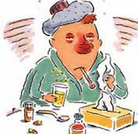

___________ __________ __________ ___________ ___________ _________
B)Dialoğu okuyup film afişine göre boşlukları tamamlayınız.(4X3=12)
MARY : Hello! Mary Pilsen is speaking.
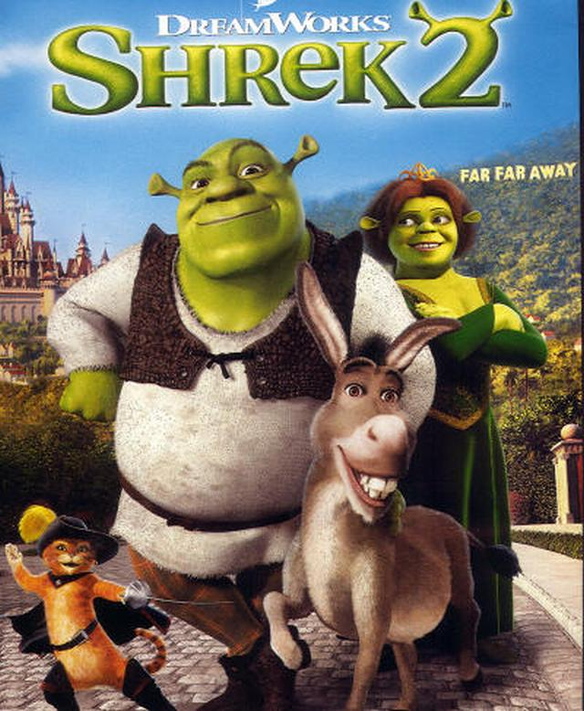
UNCLE TOM : Hi, Kate! It’s Uncle Tom. How are you?
MARY : Fine thanks. And you?
UNCLE TOM : I’m fine thank you. Let’s go to the
cinema on Sunday.
MARY : Hmm.. What’s on at the cinema?
UNCLE TOM : 1).......................................................... .
SHERK AND FIONA’S LIFE
HERK AND FIONA’S LIFE
MARY : What type of movie is it?
UNCLE TOM : .2)......................................................... .
MARY : What is it about?
UNCLE TOM : It’s about 3).......................................... .
06.00
MARY : What time is it?
UNCLE TOM : 4)............................................................ 06:00 06:00
MARY : Great! See you then.
UNCLE TOM : See you
5.30pm
5.30pm
C)Dialoğu okuyup soruları cevaplayınız.(4X3=12)
Ann: There is a birthday party at cafe today.
David: What can I do for you? What do you need?
Ann: I need a birthday cake. Can you buy a big cake for me?
David: Of course I can.
Ann: Thank you very much.
David: You are welcome.

1. Who has got a party? ......................................................................... .
2. What kind of party is it? ......................................................................... .
3. What does Ann need? ......................................................................... .
4.Where is the party? .........................................................................

D) Aşağıdaki kelimeleri resimlerle eşleştiriniz(5X3=15)
clown – birthday cake – beverages – gift - candle
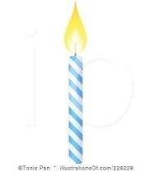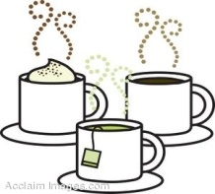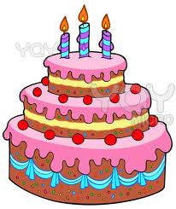

1...............2………………… 3………………… 4….…………… 5……………..……

E)Doğru olan seçeneği işaretleyiniz(10X4=40
1)A:I have got a cut on my finger.What should I do?
B:………………………..
a.You should stay at home and have a rest.
b. She shouldn’t lift heavy things . c. He shouldn’t drink cold water.
d. You should put a plaster on it

2) Merve: ……………………………
Elif: I have a sore throat.
a) What is the matter with you?
b) Where are you from?
c) Can you play hide and seek?
d) Are you a student?

3) I like………………
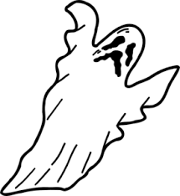
a)action film
b)horror film
c)romantic film
d)comedy film

4)My mother likes comedy film.
She thinks It is ……………..
a)comic b)horror
c)frightening d)boring

5)Ayşe:I have a headache.I am ill.
Mehmet:………………………………
a)Get well soon!
b)I have an apple.
c)She has breakfast in the morning.
d)You should brush your teeth.

6)1.January 2.February 3…………………..

a)Aprıl b)May c)March d)June

7) Donna wants to have her birthday party at home.She ask her mom:
a)When is my birthday party?
b)Can I have my birthday party at home?
c)Do you like some cake?
d)I am afraid ,I can’t.

8)Ahmet:Would you like to drink tea?
Ali:…………………………………….I like tea.
a)yes,sure.Thank you.
b)Let’s go to cinema.
c)I am sorry.
d)No ,I am busy.

9)Ayse:What is the date today?
Fatma:…………………………………….
a)It is in front of the school.
b)It is 21st March.
c)I like birthdays.
d)It is 6 o’clock.
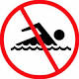
10) Ayşe:Can I swim ,mother?
Mother:No.you can’t………………….
a)You must run here.
b)You mustn’t swim .
c)You are a student.
d)You watch film.

……………………………………………….
GOOD LUCK!

