- Aşağıdaki resimleri kişilerle eşleştiriniz.
a.Murat doesn’t like playing chess. d. Mehmet likes doing puzzle.
b.Merve likes reading book. e.Ayşe likes drawing picture.
c.Mert likes eating fruit. f. Zeynep doesn’t like eating fast food.

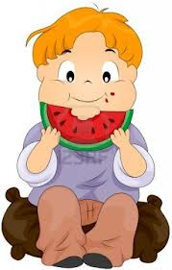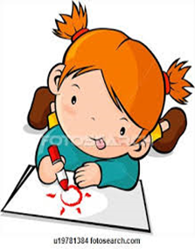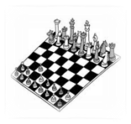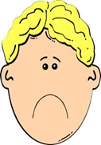
____________________ ____________________ ____________________
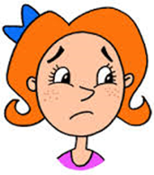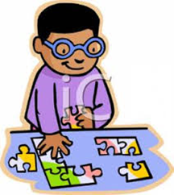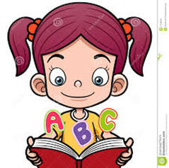
________________________ ___________________ ______________________

I) Aşağıdaki kelimeleri resimlerle eşleştiriniz.
balloons – birthday cake – beverage – gift - candle
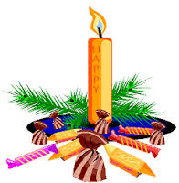
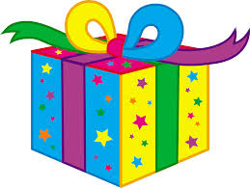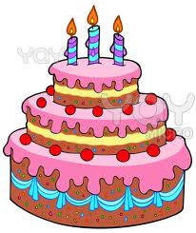

D)Aşağıdaki soruları verilen ifadelere göre cevaplayınız.
1)Can you swim? …………………………………………………………....

2)Can you take photo? …………………………………………………………………………

3)Can he play chess? ………………………………………………………………………..
4)Can she play football ? ……………………………………………………………….
G)Doğru olan cümleyi işaretleyiniz.
 | 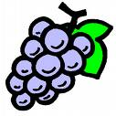 | Jim likes apples.  Jim likes grapes.
 | 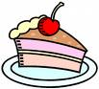 | Lisa doesn’t like cake.  Lisa doesn’t like hamburger.
 | 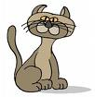 | Tom likes cats.  Tom likes dogs.
 | 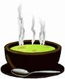 | Mary doesn’t like ice cream.  Mary doesn’t like soup.
 | 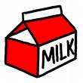 | Ahmet likes milk.  Ahmet likes tea.

