**2017-2018 EDUCATIONAL YEAR PETROL SECONDARY SCHOOL**

**1ST TERM 1ST ENGLISH EXAM FOR 6TH GRADES**

NAME_________________CLASSS_____________NUMBER____________

1. **Match the phrases to the pictures (kelimeleri uygun resmin altına yazınız ) (6*4=24)**

|  |  |  |  |  |  |  |
| --- | --- | --- | --- | --- | --- | --- |
| **play soccer** | **go online** | **watch TV** | **do karate** | **have a rest** | | **take guitar courses** |
|  | |  | | |  | |
|  | |  | | |  | |
|  | |  | | |  | |
|  | |  | | |  | |

B. **Aşağıdaki cümleleri “in”,“on”, veya “at” kullanarak tamamlayınız.(7x2=14 pts.)**

1. I go to the cinema with my friends ____ Sundays.
2. We play table tennis ____ the weekend.
3. Andy and Bill go on holiday ____ summer.
4. My sister gets up ____ 07:00 a.m.
5. Tina sleeps late ____night.
6. My brother does his homework ____ the afternoons.
7. Linda and George plays basketball ____ Saturday mornings.

**C )Aşağıdaki saatlerin kaç olduğunu yazınız.(6x3=18 pts.)**

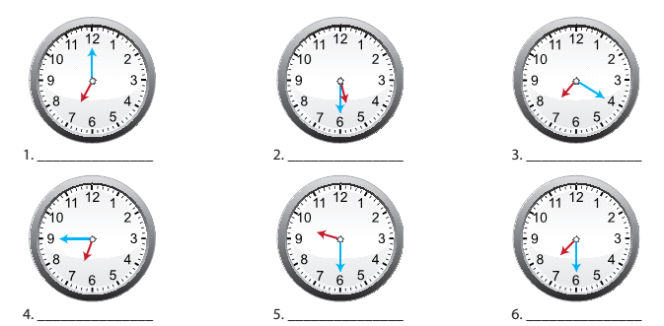

**D)Aşağıdaki soruları cevaplarıyla eşleştiriniz.(5x3=15 pts.)**

1. What time do you go to bed? **___ a)** In İstanbul.
2. Where does Eda live? ___ **b)** At 7 p.m.
3. Why do you wake up early? **___ c)** Because I go to work early.
4. How often do you meet your friends? ___ **d)** Often.
5. When does she go to the dance club? **___ e)** On Saturdays.
6. **Aşağıdaki kelimeleri sıraya koyarak cümleler oluşturunuz.(5x3=15 pts.)**
7. watch / tv / I / usually ……………………………………………………
8. Jane / listen / music / doesn’t / to / everyday …………………………………………………...
9. We / a / have / after / rest / school …………………………………………………...
10. Do/my/ ın/ the / evening / homework / ı ……………………………………………………
11. you / volleyball / Do / play / Sundays / on / ? ………………………………………………...
12. **Aşağıdaki kelimelerin Türkçe anlamını yazınız. (5*3=15)**

**Meet friends -**

**Go to dance club -**

**Have breakfast -**

**Do homework -**

**Go to bed-**

**Good luck ☺**

**Teacher of English**