2014 – 2015 EDUCATION YEAR
FATİN RÜŞTÜ ZORLU SECONDARY SCHOOL 6TH GRADE FIRST TERM SECOND ENGLISH EXAM
Name:
Surname:
Class:
Number:
A) Write name of foods . ( Yiyeceklerin isimlerini yazınız.) (10*2 p)
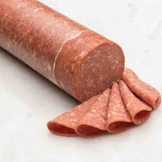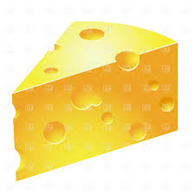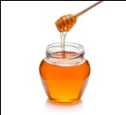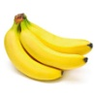
1............ 2............... 3.............. 4............... 5...............
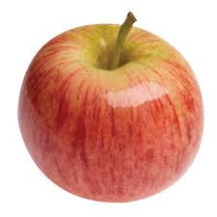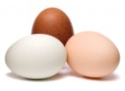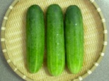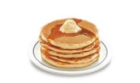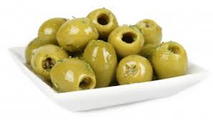
6............ 7........... 8............... 9............. 10..............

B) Write your traditional breakfast . ( Geleneksel kahvaltınızı yazınız.) (14 p)
........................................................................................................................................................................................................................................................................................................................................................................................................................................................................................................................................

C)Write the turkish meanings. (Türkçe anlamlarını yazınız.)(8*3p)
Watch TV:.................................................... Have a snack:............................................
Do Karate :................................................... Do homework:.............................................
Get Up:.......................................................... Go to School:...........................................
Go shopping:................................................. Go online :....................................................

D) Fill in the blanks according to table.(Boşlukları tabloya göre doldurunuz.)(5*3 p )
 | Driving car | Making cake | Riding a bike | Playing chess
Esma
ARİF

- ARİF………………………………………………. riding a bike.
- Esma ……………………………………………… driving a car.
- Esma …………………………………………….. making cake. stand
- ARİF ……………………………………………… making cake.
- Arif and Esma...................................... driving car.

E) Fill in the blanks with "There is "or "There are ". ( Boşlukları "There is "yada "There are " ile doldurunuz.) (5*3p)
1) ..................................................some milks ın the bottle.
2) ..................................................a bag on the desk.
3)..................................................two girl in the school garden.
4).................................................25 students in the classroom.
5)................................................ a biscuit in my bag.

F) ) Fill in the blanks with"SOME"or "ANY ".(Boşluklara "SOME"yada "ANY"koyunuz.)(4*3 p)
1)There aren't ................ milks in the bottle .
2.There are ......................apples on the table.
3. Are there...........................chocolates in your bag?
4.There is .............................cucumber in the fridge.
GOOD LUCK

