NAME SURNAME : _______________________NUMBER: __________MARK:

- Match the pictures with the activities.

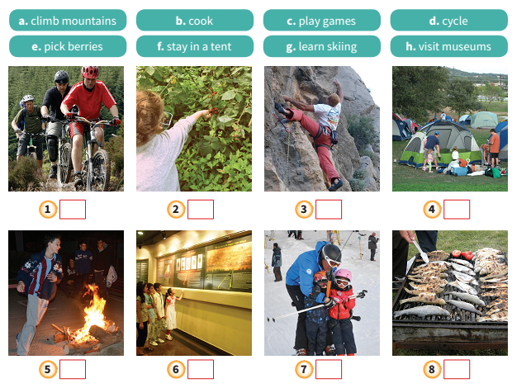

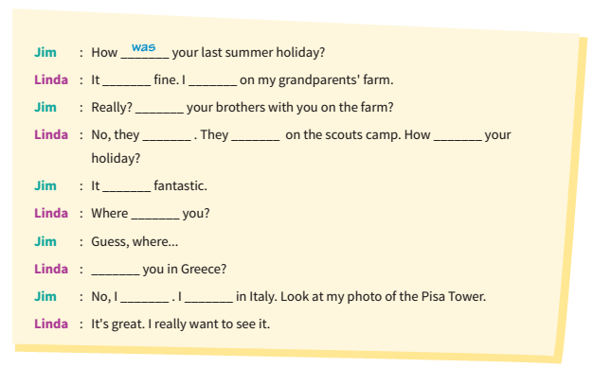
- Fill in the blanks with “was, were, wasn’t, weren’t”.

D)Aşağıdakilerden doğru olanı işaretleyiniz.
Mary : Look at that poster! There is a fun fair soon.
Jane : Great! ............................... .
A) I love fun fairs.
B) I hate fun fairs.
C) Fun fairs are boring.
D) I don’t like fun fairs.

- I don’t like reading a book. I feel really .............. .
A) happy
B) bored
C) amazed
D) excited

- Aşağıdaki eşleştirmelerden hangisi doğrudur?
A) wave – coaster
B) ghost – train
C) roller – cars
D) bumper – wheel

- Mel : ..................... is a fun ride?
Willy : Each fun ride is one token and 1 token is 3 lira.
Diyaloğu tamamlayan soru kelimesi hangisidir?
A)How much B) When C) Where D) What

- Aşağıdaki soruyu resme göre cevaplayınız.
He feels ..................... .
A) bored
B) excited
C) nervous
D) amazed

- Görseli anlatan cümle hangi seçenekte verilmiştir?
A) Pets not allowed.
B) Pay here.
C) Don’t eat or drink.
D) Danger!

- A bumper car is __________ than a roller coaster.
A) more frightened B) faster
C) slower D) more bored

8. Which is different?
A) Flowers B) Skeletons
C) Monsters D) Vampires

GOOD LUCK …

