**1,2.** ve **3.** soruları paragrafa göre cevaplayın.

 Jenny is fifteen years old.She is from France but she lives in London.Her mother Works as a nurse and her father is a Maths Teacher.She goes to school from 9:00 a.m. to 3:15 p.m.She doesn’t take bus because her father takes her to school.After school she has a snack,she does her homework,she sometımes watches TV.

**1.**Metne göre hangisi yanlıştır?

A) Jenny goes to school by bus.

B) Jenny is 15 years old.

C) Jenny’s father is a Teacher.

D) She sometimes watches TV.

**2.** ……… does Jenny Watches TV? –Sometimes.

A) How B) What time C) When D) How often

**3.** Where does she live? - …………..

A) in France B) in London C) in school D) in home

**4.** My dad comes home at ………….

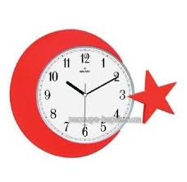

A) half past ten

B) ten to ten

C) ten past ten

D) ten o’clock

**5.** Sam likes …………………….

A) goıng shoppıng

B) listening to music

C) taking photographs

D) watchıng TV

**6.** – Does your sister like fast food?

**-………………………………**

A) Yes,, she does.

B) No, she can’t.

C) Yes,they does

D) Yes, he does.

**7.** - ……………. is your father’s job?

- He is a farmer.

A) What B) Where C) When D) how

**8.**What is the day after Sunday?

a) Sunday   b)Tuesday

c)Monday       d)Wednesday

**9.** I get up \_\_\_\_\_\_\_\_6:30 o’clock.

 A)on          B)  in          C) under         D) at

**10.** - …………………………?

- I like the blue car.

A) Have you got a car?

B) Where do you drive a car?

C) Which car do you like?

D) Do you like blue cars?

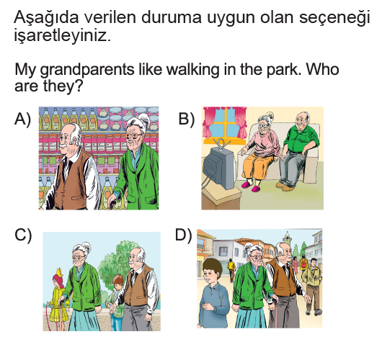

**12**. Are you a dentist[?](http://www.testimiz.com/" \t "_blank)   
Yes, ……………. 

A) he is  B) she is  C) I’m  D) you are

**13**. - ………………………..you in the living room?  
    -No, I ……………………………………

A) Are / am not                     
B) Can / can’t           
C) Have / have               
D) Are / am

**14.** ***always*** zaman zarfı cümlede hangi kelimeden sonra kullanılmalıdır?

\_John goes to bed early.

A) goes B) John C) bed D) early

**15.** Emily and Sally …………….. go out in the evenings.

A) don’t B) aren’t C) doesn’t D) isn’t

**16.** .... do you go to school? - By bus.

A) What B) Where

C) How D) How often

**17.**

I have ..... in the afternoons.After school.

A) breakfast B) lunch

C) dinner D) snack time

**18.**   
http://www.sanalokulumuz.com/sr/yuz/4.png……… a cat like sleeping?  
http://www.sanalokulumuz.com/sr/yuz/4.pngYes, ...................   
  
A) Do / it does   
B) Is / they do

C) Does / it doesn't   
D) Does / it does

**19.** " What does Gamze do in her free time? "  
Yukarıdaki sorunun cevabı hangi seçenek olamaz ? 

A) She reads story books.  
B) She watches television.

C) No, she doesn't have free time.   
D) She cooks.

**20. Waiter** : Would you like some meat sir?  
 **Man** : I am a vegetarian. I ................ eat meat .   
  
A) do   
B) never   
C) always   
D) am not