2019-2020 EDUCATION YEAR ÇUBUK SECONDARY SCHOOL
1st TERM 2nd WRITTEN EXAM for 6th GRADES

Name Surname : Class-Number :
A. Matchthegivenwordswiththepictures. (Verilen kelimelerle resimleri eşleştirin.) 10x2=20 pts
Moody -Stormy - Energetic- Scared- Freezing- foggy- lightning -Hailing -Sleepy-Snowy
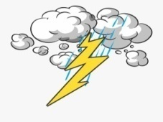
1._________________2.__________________3.___________________ 4._________________ 5.________________
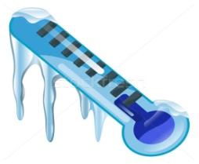
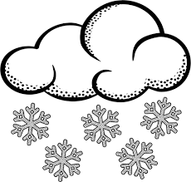

6._________________ 7.__________________ 8.___________________ 9._________________ 10._______________

B) Choose the correct comparative forms of the adjectives(Doğruseçeneğiişaretleyin.)(10x2= 20 pts)

1- Kayseri is colder/more cold than Antalya in the winter.
2-Nina is more strong /stronger than her brother.
3-Parks are more relaxing /relaxinger than shopping malls.
4-Cooking is enjoyable /more enjoyable than watching TV.
5-Bob is shorter /more short than Mike.
6-I’m morebusy / busieron Mondays.
7- My father is taller /moretall than me.
8-City life is worse /badder than country life.
9- Villages are quieter/ more quiet than cities.
10-Vera is moreyoung / younger than Tina.

C)Matchthequestionswiththeanswers.(Sorularla cevapları eşleştirin. ) ( 6x2=12 pts)
1. How do youfeeltoday ? |  | A) I alwaystakethebus.
2. What is theweatherlike in Erzurum in winter ? |  | B)It isminus 34 degreesCelsius.
3. How do yougotoschool on rainydays ? |  | C)It is sunnyand hot.
4. Why do youhatestormydays ? |  | D)It is freezing.
5. What is theweatherlike in İzmir in summer? |  | E) I feelexcited.
6. What is thetemperature? |  | F)Because I feelscaredandmoody.

D)Matchthesentenceswiththepictures. (Cümlelerle resimleri eşleştirin.) 8x2=16pts
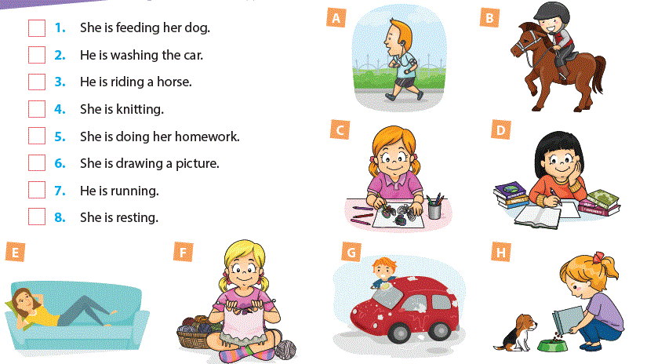

E)Fill in thegapswiththewordsgiven.(Boşlukları verilen kelimelerle doldurun.) 9x2=18 pts
winter - seasons - cold - rainy - foggy - happy - summer - sunny - windy

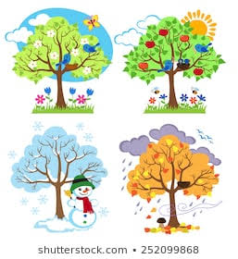

I likefour ____________. Spring is beautiful. Thereareflowerseverywhere.

____________ is myfavourite. Theweather is ____________ and hot. I alwaysfeel

_____________ because it is holiday time. Autumn is usually_________

and_____________ here. I feelbored in _______________because

it is _______________ and ________________.

F) Circletheoddone. (Farklı olanı işaretleyin.) 5x2=10 pts
1- a. skyscraper b.school c.hospital d.high
2 - a.cheeseb.start c. muffind. sausage
3- a. Spring b. Autumnc. Tuesdayd. Summer
4- a.visitb.wakeup c. taked. eggs
5- a.temperatureb. busyc.noisyd. interesting
G) Read thedialogueandfill in theblanks on thetable.(Diyaloğu okuyun ve tablodaki boşlukları doldurun.) 8x2=16 pts
MARY: What is the weather like in London? Is it sunny?
CHARLES:No, It’s not sunny. It is windy and cold in London. It’s eight degrees Celsius. I think Jack feels moody now. And It is six degrees Celsius in Birmingham. It is stormy. I am sure your mother feels anxious.
MARY: Yes, you are right. Is there any snow in the country?
CHARLES: No, not in the country. But it is snowyand foggy in Moscow. It is minus 4 degrees there.
MARY: It is freezing and I feel depressed in foggy weather.
CHARLES: Listen. In Africa in the Sahara desert it is 40 degrees Celsius.
MARY: Oh, it’s hot and dry. Of course it’s not snowy in the desert.
CHARLES: Yes, that’s right. I think you feel sleepy in a desert too.
MARY: You are right.
 | Moscow | The Sahara Desert (Africa) | London | Birmingham
Weather Condition
Emotion
English teacher

