…………………. ACADEMIC YEAR / ………………………………
7th GRADES / 2nd TERM / 1st ENGLISH EXAM
NAME/SURNAME: CLASS/NUMBER:

A. Put the following words under the correct category. (Aşağıdaki kelimeleri doğru kategorinin altına yazınınz) (20 pts)
*overweight *straight *ginger *rude *plump *of medium height
*patient *blonde *wavy *dark *selfish *short (x2)
*tall *curly *slim *fair *long *stubborn *shy

Hair style Hair length Hair color Height Weight Personality
................ ................. ............... ............. .............. ....................
................ ................ ............... .............. .............. ....................
................ ............... ............... .............. ....................
............... ....................
....................
B. Fill in the blanks with the comparative forms of the adjectives given in brackets. (Boşlukları parantez içinde verilen sıfatların karşılaştırma halleri ile doldurunuz.) (5 pts)
1. Books are .......................................... (interesting) than films.
2. Family ........................................... (important) than friends.
3. Turkish is ............................... (easy) than Russian.
4. Yesterday the weather was very bad, but today is ............................. (bad) than yesterday.
5. I’m 13 years old and my brother is 10 years old, so I’m ......................... (old) than he is.
so he’s ....................... (young) than I am.
C. Complete the dialogue with ‘’was/were’’ or ‘’wasn’t/weren’t’’. (Aşağıdaki boşukları ‘’was/were’’ ya da ‘’wasn’t/weren’t’’ ile doldurunuz) (9 pts)
Mert: (1)___________________ you at Yiğit’s party last night?
Ceyda: No, I (2) _______________. I couldn’t go.
Mert: (3) _________________ you at home?
Ceyda: Yes, I (4) __________________ .(5) ________________ Ceren and Murat with you at the party?
Mert: No, they (6) __________________ . They (7) ___________________ at the cinema.
Ceyda: (8) _______________ the party good?
Mert: Yes, it (9) _______________ great!

D. Write the past forms of the following verbs. (Aşağıda verilen fillerin geçmiş zaman hallerini yazınız) (6 pts)
1. marry ............... 4. Begin ................... 7. Stop ................. 10. Write ......................
2. move ................ 5. Drink ................... 8. Get .................. 11. Make .....................
3. enjoy ............... 6. Ride .................... 9. Read ................ 12. Produce .....................

E. Choose the correct words.(Altı çizili olan sözcüklerden doğru olanı daire içine alınız ve her öneriye uygun birbirinden farklı 5 olumlu ya da olumsuz cevap veriniz.) (10 pts)
1. Would you like to go / going to Jennifer’s slumber party?....................................................................
2. What about hang / hanging out with friends today?...........................................................................
3. Let’s have / having a rest. I feel really exhausted.................................................................................
4. Why don’t we organize / organizing a birthday party for our teacher?................................................
5. How about go / going to a cafe after work?..........................................................................................
F. Write the names of the sports . (Spor adlarını doğru resmin altına yazınız.)(7 pts)
baseball -- scuba diving -- cycling -- sailing -- parachuting -- table tennis -- swimming
horse riding -- gymnastics -- rollerblading -- skiing -- dancing

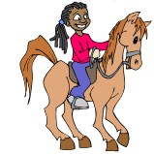
- yazınız
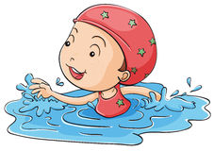
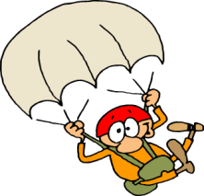
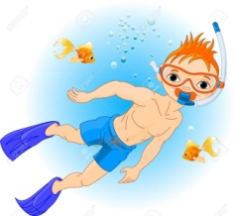
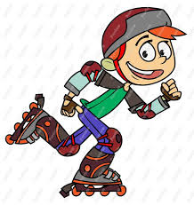
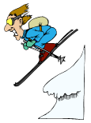
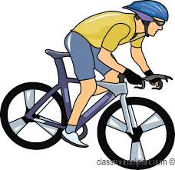

……………… ………….…… …………………….. …………………….. ……………….. ………………… ……......
G. Circle the correct option. (Doğru seçeneği daire içine alınız.) (5 pts)
1. Mert is fond of indoor/outdoor activities. Table tennis is his favourite.
2. Kate really likes tennis and her favourite tennis equipment/player is Rafael Nadal.
3. My brother Charlie is good at team sports/individual sports, especially horse-riding.
4. David is crazy about football and his favorite team/spectator is Manchester City.
5. Germany became the draw/winner of 2014 FIFA World Cup in Brazil.

H. Fill in the blanks with ‘’should’’ or ‘’shouldn’t’’. (Aşağıdaki cümleleri should ya da shouldn’t ile doldurunuz) (5 pts)
1. We ........................ hunt animals, especially endangered animals.
2. We .......................... wear fur.
3. We .......................... use harmful chemicals.
4. We ..................... protect the habitats in national parks,nature reserves and wilderness areas.
5. We ....................... save energy by turning off electric devices when we are not using them.

I. Circle the correct option. (Doğru seçeneği daire içine alınız.) (8 pts)
1. There are a few / a little money in my pocket.
2. How much / How many butter is there in the fridge?
3. How many / how much students are there in the class?
4. There are a few / a little shopping malls around.
5. Michael has got a little /a lot of books in his library.
6. How many / much milk is there for breakfast?
7. There are some / any eggs in the fridge.
8. We don’t need some / any beverages.

J. Write the Turkish meanings of the words given below. (Aşağıda verilen kelimelerin Türkçe karşılıklarını yazınız.) ( 21 pts)
1. superstition: 8. Protect: 15. Educational:
2. evil-eye: 9. Recycle: 16. Violence:
3. magic: 10. Encourage: 17. Suitable:
4. make a wish: 11. Documentary: 18. Recommend:
5. wealth: 12. Commercial: 19. Order:
6. Extinction: 13. Addict: 20. Host:
7. Population: 14. Amusing: 21. Accept:
K. Translate the following sentences. (Aşağıdaki cümleleri çeviriniz) (1 and 2=1pt, 3=2pts)
1. My brother prefers playing computer games to doing homework. ___________________________
2. I prefer reading books to watching TV. _________________________________________________
3. Babam haber izlemeyi dizi seyretmeye tercih eder. _______________________________________

