Name-Surname : …………………………………..
Class- number : …………………………………

1. Real Madrid won a gold …………………… in UEFA Cup.
- Spectator B) Medal
- Equipment D) Prize

2. Gökhan ………… from the university in 2010 and ……….
To England.
- Lived / move
- Graduates / goes
- Celebrated / did came
- Graduated / moved

3. Serdar likes running. He wants to be a/an ………
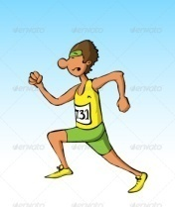
- Footballer B) Boxer
C) Athlete D) Cyclist

4. I like …………………………………..very much.
- Swimming B) snowboarding
C)skiing D) skating

5. - We should ……………… endangered animals.
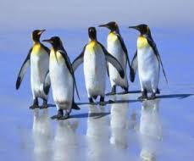
A) protect B)kill
C) hunt D) plant

6. Elephant lives in forest. It is elephant’s ………………
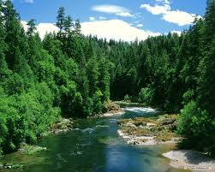
A) protect B) habitat
C) extinct D) pet trade

7. People hunt lions, tigers, giraffes for their …………………..…

A) trunk C) wing B) fur D) tail

8. - ……………………… does a panda live? - for 50-60 years.
A) What B) How long C) How tall D) When

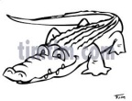
9. Snakes, Crocodiles, Lizards lay eggs.
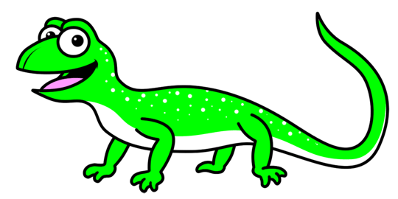
They are ……………….
- Mammals B) Fish
C) Herbivores D) Reptiles

10.Aşağıdaki cümlenin Türkçe anlamı hangi şıkta doğru olarak verilmiştir?

A) Jimnastik için bedava giriş bileti vardı.
B) Jimnastik salonu için serbest girerdi.
C) Serbest giriş için jimnastik.
D) O jimnastik salonuna bedava girdi.

11. Aşağıdaki maili en iyi tamamlayan cümle hangisidir?

A) I did had an accident last week.
B) my father has an accident.
C) my father had an accident yesterday.
D) I have an appointment yesterday.

12. Habitat means; …………………….

A) removal of a forest.
B) extinction of a spesific animal.
C) areas where people and animal are.
D) places where animals and plants live.

13. What kinf of sport does İbrahim Kutluay do?

A) Wrestling B) Basketball
C) Football D) Scuba diving

14,15,16. soruları aşağıdaki parçaya göre cevaplayın.

14. Where does Alex live?

- He lives in Germany.
- He live in Germany.
- I live in Germany.
- He lives in primary school.

15. How often does he have training.

- I always have training.
- He usually has training.
- He always have training.
- He trains every morning.

16. What happened last week?

- He was at home and bored
- He has an accident and injure his leg.
- He had an accident and injured his leg.
- He couldn’t go out.

17. *Ankara: 23ºC
* Van : 10ºC
*Antalya: 33 ºC
Which one is TRUE ? Hangisi doğrudur?

- Ankara is colder than Antalya.
- Van is hotter than Antalya.
- Antalya is colder than Ankara.
- Ankara is hotter than Antalya.
18. ………………………. Studying English?

- Shall we
- Let’s
- How about
- Why don’t you

19. ve 20. soruları aşağıdaki tabloya göre cevaplayın. Look at the table and answer the questions.
 | Play basketball | Go skating | Have breakfast
I | 0 | ** | ****
Sarah | *** | * | 0
William | ** | **** | ***

0 : never * : sometimes ** : often
*** : usually **** : always
19. Tabloya göre hangisi yanlıştır?

- I always have breakfast.
- William often plays basketball.
- Sarah never has breakfast.
- I sometimes go skating.

20. …………… does Sarah goes skating?
- She ………………….. goes skating.

- How often / sometimes
- When / sometimes
- How often / usually
- When / usually

…………………………………
ENGLISH TEACHER .

