…………
EĞİTİM VE ÖĞRETİM YILI YEŞİL ……………… 8/… SINIFI
İNGİLİZCE DERSİ 1. DÖNEM 3. YAZILISI
NOT:
ADI SOYADI:………………………… NU:………….. PUAN:………

1.
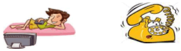
While Tom _______ TV, the phone ______
a) was watching / was ringing
b) watched / was ringing
c) watched / rang
d) was watching / rang

2. If you eat junk food , you can’t ________ your acnees.
a) product b) rinse
c) get rid of d) scrub

3.
Martin is a ____dancer. He dances ____.
a) goodly / good b) well / good
c) good / goodly d) good – well

4.
Albert is very good at solving problems.
a) He has verbal linguistic intelligence.
b) He has musical intelligence
c) He has mathematical intelligence.
d) He has intrapersonal intelligence

5. ____we were looking at the album, Barış came.
a) While b) After
c) Before d) When

6.
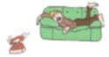
________ the phone rang, I was sleeping.
a) While b) When
c) Because d) After

7.
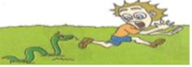
While the children _____in the garden , they ___a snake
a) were playing / saw
b) played / saw
c) played / was seeing
d) were playing / were seeing

8.
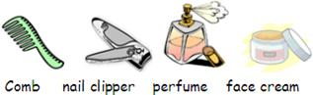
Aşağıdakilerden hangisi yukarıdaki ile aynı sıradadır?
a) skin care – hand care – body care – hair care
b) body care – skin care – hair care – hand care
c) hand care – body care – skin care – hair care
d) hair care – hand care – body care – skin care

9.
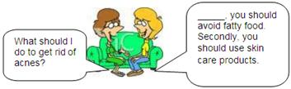
a) Firstly b) Finally
c) Also d) Then

10.
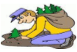
Mete planted a tree by _____.
a) herself b) themselves
c) yourself d) himself

11.When she was 3 years old, she ______ swim.
a) can b) will
c) are d) Could

12.
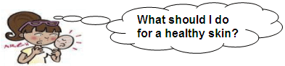
Soruya verilebilecek uygun cevabı bulunuz.
a) You shouldn’t eat fruit and vegetables.
b) You should (bilgi yelpazesi.net) go to bed late.
c) You shouldn’t use personal care products.
d) You should stop eating junk food.

13.
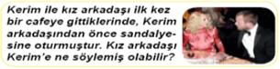
a) You are a polite person
b) You are a kind person
c) You are a rude person
d) You are a nice person

14. Aşağıdakilerden hangisi dış görünüş ile ilgilidir?
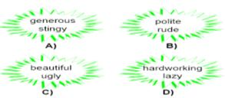

15.
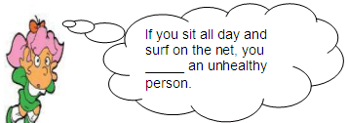
konuşmayı tamamlayan seçeneği işaretleyiniz.
a) will be b) be
c) won’t be d) can’t be

good luck....... :) :) :)

