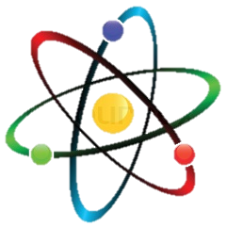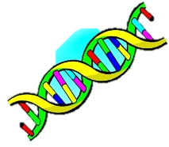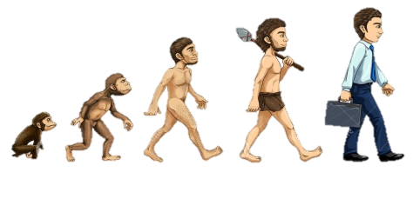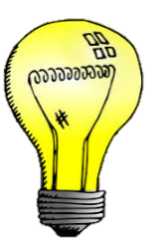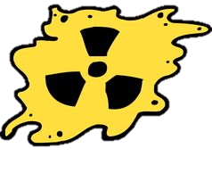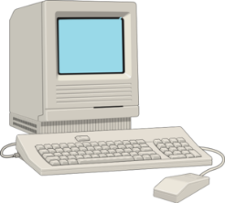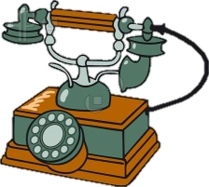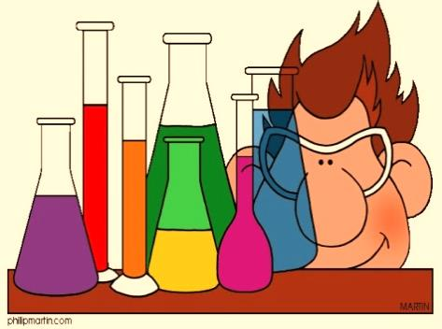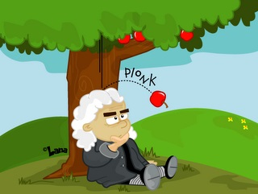

*Fill in the blanks using the verbs in the brackets:*

1. Michelangelo _ _ _ _ _ to paint the Sistine Chapel in 1508 and it _ _ _ _ 4 years to finish it. (begin/take)

2. An apple _ _ _ _ on Isaac Newton’s head and so the gravitation theory _ _ _ _ _ _ _ _ in the XVIII century. (fall/appear)

3. Vincent van Gogh _ _ _ _ _ _ the “tortured artist” because he

_ _ _ off his right ear. (became/cut)

4. Alexander Fleming _ _ _ _ _ _ _ _ _ _ penicillin over 80 years ago and the first use _ _ _ to cure conjunctivitis. (discover/be)

5. In 1770, Nicolas Joseph-Cugnot _ _ _ _ _ the first steam powered auto-mobile that _ _ _ _ _ at a speed near 4 km/h. (build/move)

6. Aurel Vlaicu _ _ _ _ _ _ _ _ the first powered airplane that

_ _ _ _ in 1919 over Cotroceni, Romania. (invent/fly)

7. Ana Aslan _ _ _ _ _ that procaine has anti-aging effects on skin and afterwards she _ _ _ _ _ _ _ the Gerovital drug. (find/create)

8. Before the invention of the refrigerator, people _ _ _ _ ice-houses that _ _ _ _ underground chambers close to natural sources of ice. (use/be)

9. Mascara _ _ _ _ _ _ _ to be worn by women and men since ancient Egypt because they _ _ _ _ _ _ _ it will protect their souls from evil spirits. (start/think)

10. John Pemberton _ _ _ _ Coca-Cola in 1886 as a medicine but in the end he _ _ _ _ it as a beverage creating the most well-known soda. (make/sell)

*Find the inventions for each inventor:*

1. Thomas Edison

2. Alexander Bell

3. Charles Darwin

4. Alfred Nobel

5. Niels Bohr

6. Rosalind Franklin

7. Steve Jobs

8. Marie Curie

*Write the Past Simple form for the following verbs:*

* dream - _ _ _ _ _ _
* buy - _ _ _ _ _ _
* choose - _ _ _ _ _
* create - _ _ _ _ _ _ _
* do - _ _ _
* draw - _ _ _ _
* develop - _ _ _ _ _ _ _ _ _
* feel - _ _ _ _
* fight - _ _ _ _ _ _
* get - _ _ _
* grow - _ _ _ _
* have - _ _ _
* hide - _ _ _
* know - _ _ _ _
* learn - _ _ _ _ _ _
* put - _ _ _
* read - _ _ _ _
* rise - _ _ _ _
* run - _ _ _
* stand - _ _ _ _ _
* send - _ _ _ _
* speak - _ _ _ _ _
* stick - _ _ _ _ _
* teach - _ _ _ _ _ _
* throw - _ _ _ _ _
* win - _ _ _

**Great inventors, artists and scientists**

**Past Simple of the regular and irregular verbs**