**A-Read the paragraph and answer the questions.(2x5:10)**



This is Claire Bloom. She is a secretary. She works in an office. It’s half past eight on Tuesday. She is in her living room and she is drinking tea. She is at home today because she is ill. She is happy now. Because she is resting at home.

1-What is her name?........................................... ............................................................

2-What does she do?.............................................. .................................................. …....

3-Where is she now?............................................. .................................................. .......

4-What is she doing?.............................................. .........................................................

5-Why is she at home today ?.......................................... .................................................

**B-Look at the family tree and fill in the blanks.(10x1:10)**

1-Sue is George’s ……………………………..

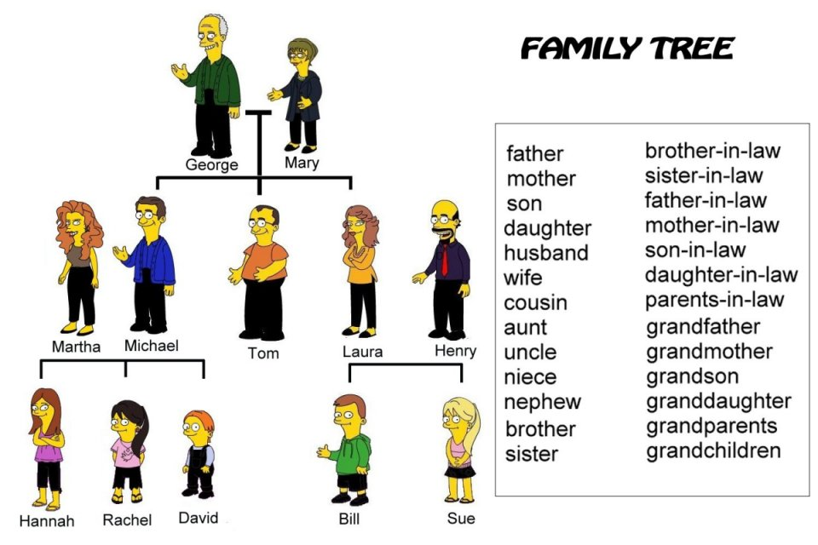

2-George is Sue’s……………………………

3-Michael is Martha’s………………….

4-Laura is Tom’s…………………………

5-David is Rachel’s………………………

6-Sue is Michael’s…………………………

7-Bill is Laura’s…………………………

8-Bill is Hannah’s…………………………

9-Laura is Henry’s…………………………

10-Michael is David’s………………………………

**C-Fill in the blanks with the appropriate job.(principal/doctor/actor/scientist/conductor)**

**(2x5:10)  
1.** A ......................... works in a hospital.

**2.** An ......................... performs in a film.

**3.** A ......................... use laboratory equipment.

**4.** A ......................... is responsible for the school management.

**5.** A ......................... conducts an orchestra.

**D-What time is it?(5x2:10)**

1- 8:15………………………………………………………

2-10:30…………………………………………………….

3-12:45……………………………………………………..

4- 4:05………………………………………………………

5- 6:20………………………………………………………

**E)Fill in the blanks using suitable possessive adjectives.(10x1:10)**  
1) Steve is here. These are __________books.  
2) Orhan and I are brothers and this is ________ house.  
3) _______names are Frank and George. We are doctors.  
4) Are you John? Is this _________ book?  
5) You are a teacher and _________ class is 11A.  
6) This is our car. _________color is blue.  
7) Hello. I’m Tina. This is _____ mother. ________ name is Betty.  
8)They are sisters. ________ names are Hale and Jale.  
9)My favorite pop stars are Rihanna and Madonna.   
I think _________ music is great.

**F) Circle the correct one from the underlined words.(6x2=12)**

1- My grandmother ***has / have*** got ten grandchildren.

2- In our family my father ***does / makes / gets*** the shopping.

3-A bird ***can / can’t*** fly.

4-I hate vegetable but my sister ***like / is liking / likes*** eating all the vegetables.

5-A ***carpenter / doctor / scientist*** works in a laborotary and does experiment.

6-George and Mary ***are studying / study / is studying*** Maths in their room now.

**G-Answer the following questions.(6x3:18)**

1-What is your English teacher’s name?.........................................................................................................

2-Where are you from?....................................................................................................................................

3-What is your job?..........................................................................................................................................

4-Who is the principal of your school?............................................................................................................

5-Who is the first president of Turkish Republic?............................................................................................

6-What’s your favourite lesson?.......................................................................................................................

**H) Write sentences with the given words : Verilen kelimelerle cümle oluşturun.(4x3=12)**

1- taking / I / photos / am / now ………………………………………………………………………………

2- usually / she / tea / drinks / for her breakfast…………………………………………………………… …

3-my sister / play the guitar / can / well………………………………………………………………………

4-responsible for / a principal / is / the school management………………………………………………….