RECEP ATAKAŞ VOCATIONAL AND TECHNICAL ANATOLIAN HIGH SCHOOL
2016 - 2017 ACADEMIC YEAR / ENGLISH LESSON / 9th GRADE / 2nd TERM / 1st EXAM

Name and Surname: Class: 9/AMP - _____ Score:
Number: Time: 40’ (minutes)

(READING) PART A: Soruları paragrafa göre yalnızca “doğru (true) veya yanlış (false)” olarak cevaplayınız. (10p)

London is the most popular city in the world for tourists to visit. It is the capital city of both England, and the United Kingdom. It has 19 million visitors every year. There are many famous attractions like Buckingham palace, Big Ben and the Houses of Parliament. One of the newest attractions is the London Eye.
The most famous museum is the Victoria and Albert Museum, and it has a very large selection of decorative arts.
Do you like shopping? Harrods is probably the most famous department store in the whole world.

- London is not the most popular city in the world. ______
- London has 19 billion visitors every month. ______
- Big Ben is in London. ______
- Buckingham Palace is a famous attraction in London. ______
- Harrods is a famous shopping center in London. ______

(VOCABULARY) PART B: Aşağıdaki sözcüklerin Türkçe anlamlarını boşluğa yazınız. (10p)

- underground _____________
- coach _____________
- port _____________
- bridge _____________
- square _____________
- falls _____________
- go swimming _____________
- fly _____________
- buy souvenirs _____________
- travel by bus _____________

(GRAMMAR) PART C: Cümlelerdeki boşlukları “was” veya “were” ile uygun şekilde doldurunuz. (20p)

(GRAMMAR) PART D: Aşağıdaki boşlukları geçmiş zamanda kullanılan “time expressions” (last, yesterday, ago veya in) ile uygun şekilde doldurunuz. (10p)

Page 1
(VOCABULARY) PART E: Aşağıdaki kültürel yiyecekleri ülke adlarıyla eşleştiriniz ve ülke adlarını kutuculara yazınız. 1 resim ekstradır, bu resmi bulup altındaki kutucuğa (x) koyunuz. (10p)
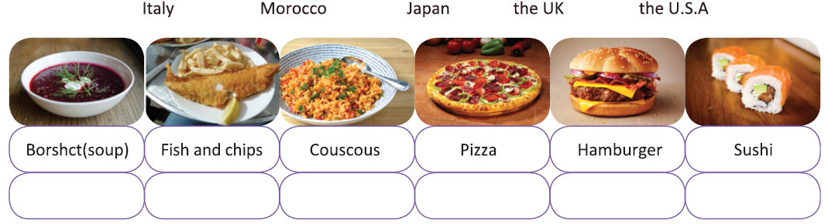

(GRAMMAR) PART F: Aşağıdaki cümlelerde yer alan boşlukları cümle sonundaki parantezleri dikkate alarak “would like” (to) veya “want” (to) ile uygun şekilde doldurunuz. (10p)

- I ____________ coffee, please. (to waiter)
- Ali ____________ eat pizza. (in restaurant)
- I ____________ have some soup. (to mother)
- I ____________ eat hamburger today. (to sister)
- I ____________ buy a kilo of tomato. (in market)
- I ____________ coke at lunch. (to father)
- I ____________ play tennis. (to teacher)
- I ____________ go out. (to friend)
- I ____________ a delicious breakfast (to waiter).
- I ____________ chocolate, dad! (to father)

(GRAMMAR) PART G: Aşağıdaki cümleleri geçmiş zaman yapısını kullanarak pozitif, negatif veya soru cümlesi olarak yeniden yazınız (20p)

1. Did James build this ancient tomb?
_________________________________ (+)
_________________________________ (-)

2. The teacher drove his car.
_________________________________ (-)
_________________________________ (?)

3. They didn’t study for the exam.
_________________________________ (+)
_________________________________ (?)

4. My sister made a birthday cake.
_________________________________ (-)
_________________________________ (?)

5. Did John put his pencil on the table?
____________________________________ (+)
____________________________________ (-)

(WRITING) PART H: Ziyaret etmek istediğiniz bir şehir hakkında tanıtıcı bir metin yazınız. Metinde o şehrin nüfusundan, turistik yerlerinden ve alışveriş merkezlerinden bahsediniz. (En az 5 cümle) (10p)
__________________________________________________________________________________
__________________________________________________________________________________
__________________________________________________________________________________
__________________________________________________________________________________
__________________________________________________________________________________
__________________________________________________________________________________

“To make your children capable of HONESTY is the beginning of education”
“Eğitimin başlangıcı çocuklarınızı DÜRÜST yetiştirmekten geçer.”

Başarılar!
Best of Luck!

English Teacher

Page 2

