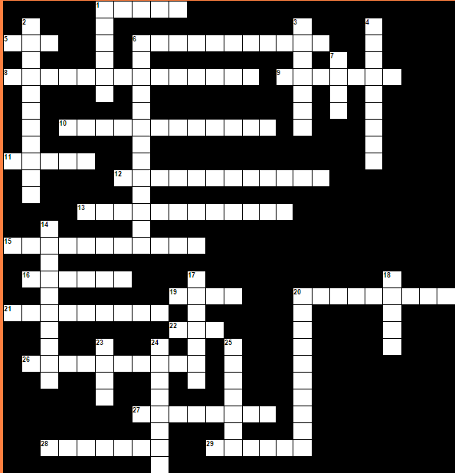

|  |  |  |  |  |  |  |  |  |  |  |  |  |  |  |  |  |  |  |  |  |  |  |  |  |  |  |  |  |  |  |  |  |  |  |  |  |  |  |  |  |  |  |  |  |  |  |  |  |  |  |  |  |  |  |  |  |  |  |  |  |  |  |  |  |  |  |  |  |  |
| --- | --- | --- | --- | --- | --- | --- | --- | --- | --- | --- | --- | --- | --- | --- | --- | --- | --- | --- | --- | --- | --- | --- | --- | --- | --- | --- | --- | --- | --- | --- | --- | --- | --- | --- | --- | --- | --- | --- | --- | --- | --- | --- | --- | --- | --- | --- | --- | --- | --- | --- | --- | --- | --- | --- | --- | --- | --- | --- | --- | --- | --- | --- | --- | --- | --- | --- | --- | --- | --- |
| |  |  | | --- | --- | | **Yatay:** | | | **1.** | **Sandelye** | | **5.** | **Kapı** | | **6.** | **Küvvet,Lavabo** | | **8.** | **Elbise dolabı** | | **9.** | **Ayna** | | **10.** | **Bulaşık makinesi** | | **11.** | **Lamba** | | **12.** | **Yazı masası** | | **13.** | **Askı(lık** | | **15.** | **Kitaplık** | | **16.** | **Duş** | | **19.** | **Kanepe,koltuk (birden fazla kişi)** | | **20.** | **Çöp kovası** | | **21.** | **Televizyon** | | **22.** | **Saat** | | **26.** | **Çeşme** | | **27.** | **Bilgisayar** | | **28.** | **Komidin** | | **29.** | **Merdiven** | | |  |  | | --- | --- | | **Dikey:** | | | **1.** | **Koltuk (tek kişilik)** | | **2.** | **Buz dolabı** | | **3.** | **Halı,kilim** | | **4.** | **Banyo küveti,duş teknesi** | | **6.** | **Çamaşır makinesi** | | **7.** | **Yatak** | | **14.** | **Ayakkabılık** | | **17.** | **Perde** | | **18.** | **Masa** | | **20.** | **Mikrodalga** | | **23.** | **Ocak** | | **24.** | **Fırın** | | **25.** | **Pencere** | |





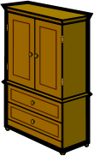

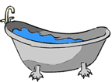

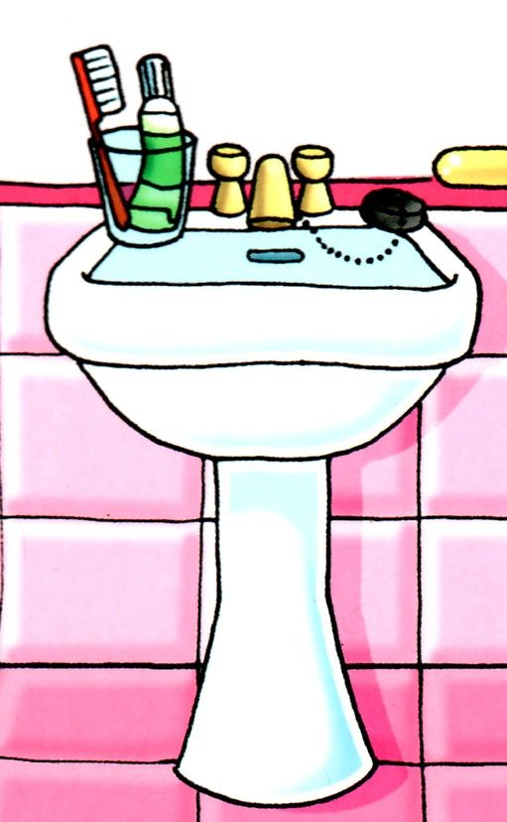

• Teppich (1)

• Sofa (2)

• Spiegel (3)  
• Herd (16)

• Mikrowelle (4)

• Stuhl (5)  
• Stehlampe (20)

• Bett (6)  
• Fernseher (17)

• Badewanne (7)  
• Waschmaschine (18)

• Kühlschrank (8)

• Tisch (9)

• Kleiderschrank (10)  
• Bücherregal (19)

• Waschbecken (11)

• Kommode (12)

• Dusche (13)

• Kleiderhaken (14)  
• Sessel (15)

