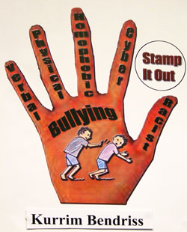

17

16

15

14

12

10

11

10

9

8

7

6

5

4

2

3

1

1. A person who has been attacked or hurt by someone.

2. A false spoken statement that is made to cause people to have a bad opinion of someone.

3. A person who is standing near but not taking part in what is happening.

4. Someone who frightens, hurts, or threatens smaller or weaker people.

5. To annoy or bother someone in a constant or repeated way.

6. A person that gives help to another person.

7. To say insulting things to someone in order to make that person angry.

8. A trick that is done to someone usually as a joke.

9. To laugh at or make fun of someone in an unkind way.

10. To make someone afraid.

11. To refuse to accept bad treatment from someone.

12. Suicide caused by cyber bullying.

13. A form of bullying that involves words.

14. A person at which an attack is aimed.

15. To do or say something that is offensive to someone (that shows lack of respect).

16. Extreme physical or mental pain.

17. An act that is meant to trick or deceive people.