Araştıran-Hazırlayan:Gülnaz AKGÜN

İngilizce Öğretmenliği Alan Bilgisi

FAMOUS WRITERS & THEIR WORKS
Old English (Anglo-Saxon Period):
writers: Caedmon and Cynewulf.
work: Beowulf (by anonymous).
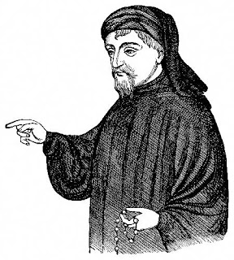
1200-1500: Middle English Period :
Geoffrey Chaucer's(1343-1400) :
.The Canterbury Tales
. Troilus and Criseyde
.Book of the Duchess.
Other Major Poems
.The House of Fame
.The Parliament of Fowles Geoffrey Chaucer

.The Legend of Good Women
.Prose Treatises
.Treatise on the astrolabe .Short Poems .The Complaint of Chaucer to His Purse Truth
.Gentilesse
.Merciles Beaute .Lak of Stedfastnesse .Against Women Unconstant
Thomas Malory's (1405-1471) :
Morte d'Arthur.
work: Sir Gawain and the Green Knight (by anonymous).
1500-1660: The English Renaissance 1500-1558: Tudor Period (Humanist Era)
The Humanists:

Sir Thomas More (1478-1535) :
Utopia The History of King Richard the Third, The Life of Pico della Mirandola, The Four Last Things, A Dialogue Concerning Tyndale, The Confutation of Tyndale's Answer, A Dialogue of Comfort Against Tribulation and Sadness of Christ .
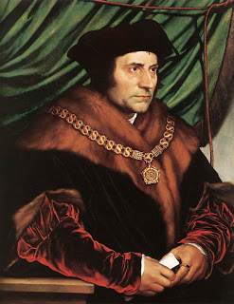

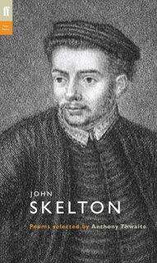
John Skelton (1460-1529):
.A ballade of the Scottysshe Kynge

Sir Thomas Wyatt(1503-1542):
My Lute Awake! Once, As Methought, Fortune Me Kissed They Flee From Me The restful place ! renewer of my smart It may be good, like it who list In faith I wot not what to say There Was Never Nothing More Me Pained Patience ! though I have not Though I Cannot Your Cruelty Constrain Blame Not My Lute My Pen ! Take Pain The heart and service to you proffer'd Is It Possible? And Wilt Thou Leave Me Thus? Since so ye please to hear me plain Forget Not Yet The Tried Intent What Should I Say!
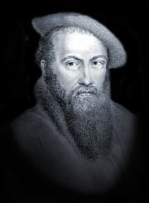

The Renaissance Period consists of four subsets:
1. 1558-1603: The Elizabethan Age (High Renaissance):
William Shakespeare (1564-1616):
Comedies: All's Well That Ends Well, As You Like It, The Comedy of Errors, Love's Labour's Lost, Measure for Measure, The Merchant of Venice, The Merry Wives of Windsor, A Midsummer Night's Dream, Much Ado About Nothing, The Tempest, Twelfth Night, or What You Will, The Two Gentlemen of Verona, The Two Noble Kinsmen, The Winter's Tale
Histories: King John, Richard II, Henry IV, part 1, Henry IV, part 2, Henry V, Henry VI, part1, Henry VI, part 2, Henry VI, part 3, Richard III,Henry VIII
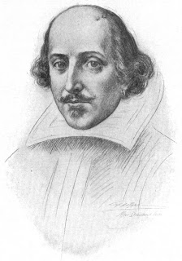
Tragedies: Romeo and Juliet, Coriolanus, Titus Andronicus, Timon of Athens, Julius Caesar, Macbeth, Hamlet, Troilus and Cressida, King Lear, Othello, Antony and Cleopatra.Poems: Shakespeare's Sonnets, Venus and Adonis, The Rape of Lucrece, The Passionate Pilgrim, The Phoenix and the Turtle, A Lover's Complaint.

William Shakespeare

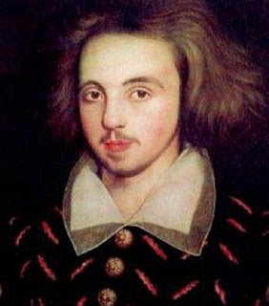
Christopher Marlowe(1564-1593):
.The Tragical History of Doctor Faustus . The Jew of Malta Massacre at Paris Tamburlaine the Great
.Part 1 Tamburlaine the Great . Part 2 Lucan's First Book Edward II Dido Queen of Carthage Hero
.Leander Ovid's Elegies .The Passionate Shepherd to his Love

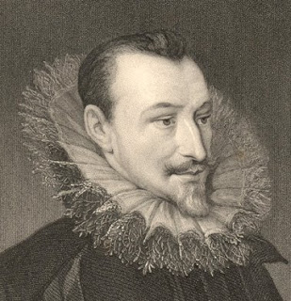
Edmund Spenser(1552-1599):
.The Faerie Queene
.Iambicum Trimetrum
.The Shepheardes Calender

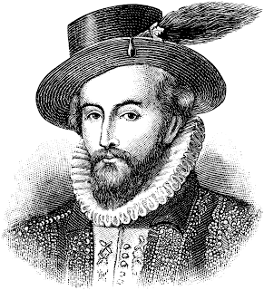
Sir Walter Raleigh(1552 – 1618):
.What is Our Life
.The Ocean to Cynthia
.The Lie.

Sir Walter Raleigh

Ben Jonson(1573-1637):
An Hymn to God the Father An Hymn on the Nativity of My Savior An Epitaph on Master Vincent Corbet On the Portrait of Shakspeare To the Memory of My Beloved the Author, Mr. William Shakespeare To Mr. John Fletcher, Upon His "Faithful Shepherdess" Epitaph on the Countess of Pembroke Epitaph on Michael Drayton To His Much and Worthily Esteemed Friend, the Author To My Worthy and Honored Friend, Master George Chapman
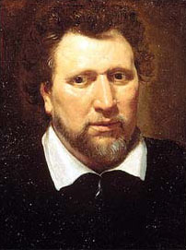

Ben Jonson

2. 1603-1625:The Jacobean Age {Mannerist Style (1590-1640) other styles: Metaphysical Poets; Devotional Poets}:
John Donne(1572-1631):
Song A Hymn to God the Father Death, Be Not Proud Confined Love The Dissolution Oh my black soul! now art thou summoned Father, part of his double interest A Hymn to Christ at the Author's Last Going into Germany
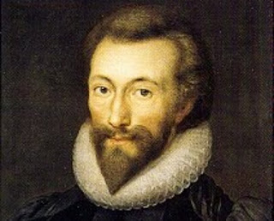

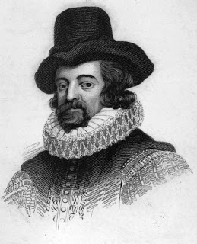
Francis Bacon (1561-1626):
The Advancement of Learning, The Essays, The New Atlantis, Valerius Terminus of the Interpretation of Nature

Thomas Middleton (1580-1627):
The Phoenix Michaelmas Term A Mad World, My Masters A Trick to Catch the Old One The Puritan
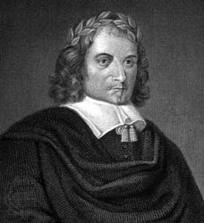

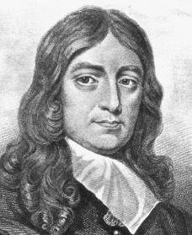
3.1625-1649: The Caroline Age : John Ford, John Milton
John Milton (1608-1674):
.Lycidas .Paradise Lost .Paradise Regained
John Ford (1586-1640):
.Fame's Memorial Christ's Bloody Sweat, attr .Honour Triumphant .The Witch of Edmonton .The Sun's Darling
.The Lover's Melancholy .Contention of a Bird and a Musician .The Broken Heart .A Bridal Song Love's Sacrifice 'Tis Pity .She's a Whore Perkin Warbeck .The Fancies .Chaste and Noble .The Lady's Trial
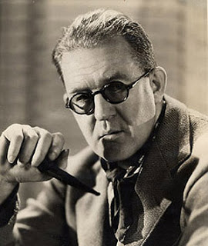

4. 1649-1660: The Commonwealth Period (which is also known as the Puritan & The Protectorate (Baroque Style, and later, Rococo Style)
The Neoclassical Period: political writings of John Milton, Thomas Hobbes' political treatise Leviathan, and the prose of Andrew Marvell.
Andrew Marvell (1621-1678):
.To his coy mistress
The Neoclassical Period
can be divided into three subsets:
1. 1660-1700: The Restoration:
John Milton (1608-1674):
Paradise Lost and Paradise Regained.
John Dryden (1631-1700), John Wilmot 2nd Earl of Rochester (1647–1680), satirical poet; and John Locke.
John Dryden
2. 1700-1800: The Eighteenth Century(The Enlightenment; Neoclassical Period; The Augustan Age)
The Augustan Age:
Jonathan Swift
Alexander Pope
Daniel Defoe: Robinson Crusoe, (first English novels by Defoe) and Pamela by Samuel Richardson.
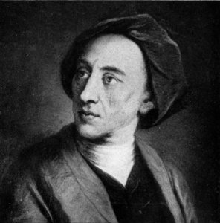
Alexander Pope (1688-1744):
An Essay on Criticism The Rape of the Lock The Dunciad

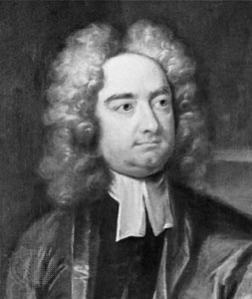
Jonathan Swift (1667-1745):
.A Modest Proposal
.Gulliver's Travels
.Lady´s Dressing room
.Strephon and Chloe
.Cassinus and Peter
3. The Age of Sensibility.
Samuel Johnson and Henry Fielding
Henry Fielding (1707-1754)
.Tom Jones
Samuel Johnson (1709-1784):
.A Dictionary of the English Language
.To the Right Honorable the Earl of Chesterfield
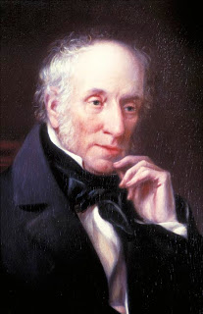
1785-1870: Romanticism (The Age of Revolution) William Blake, William Wordsworth, S.T. Coleridge, George Gordon Byron, Percy Bysshe Shelley, John Keats, Jane Austen.
William Wordsworth (1770-1850):
London 1802
Ode: Intimations of Immortality
.The Prelude
.To a Skylark
.Tintern Abbey

Samuel Taylor Coleridge (1772 – 1834):
.The Rime of the Ancient Mariner
.Chrisabel
.Kubla Khan
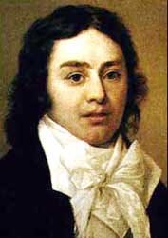

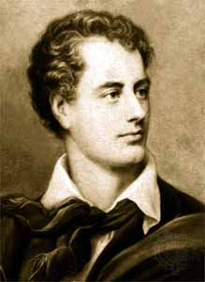
George Gordon Byron (1788-1824):
.Childe Harold's Pilgrimage
.Don Juan Song for the Luddites
.The Isles of Greece

1870-1914: Victorian Period (Early, Middle and Late Victorian
Charles Dickens, the Brontës, George Eliot, Robert Browning, Alfred, Lord Tennyson, Thomas Hardy.
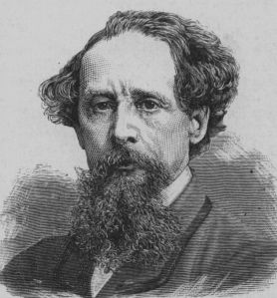
Charles Dickens (1812-1870):
.Great Expectations
.Hard Times
.The Old Curiosity Shop
.Dombey and Son
.A Tale of Two Cities
.Oliver Twist

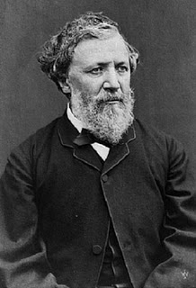
George Eliot (1819-1880):
.Middlemarch
.The mill on the floss
.George Eliot
.Robert Browning (1812-1889):
.The Ring and the Book
.My Last Duchess

1914-1945: Modern Period:
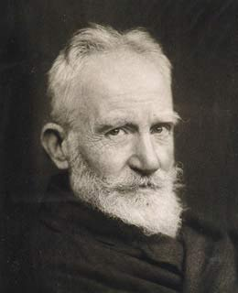
George Bernard Shaw, John Galosworthy, William Butler Yeats, James Joyce, D.H. Lawrence, T.S. Eliot.
George Bernard Shaw(1856-1950):
. Candida
.Pygmalion
.An Unsocial Socialist Arms and the Man
.Caesar and Cleopatra
.The Irrational Knot
.Cashel Byron's Profession

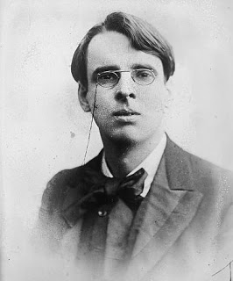
William Butler Yeats (1865-1939):
.The Island Of Statutes Iris
.Fairy Tales
.On Baile' Strand
.The Hour Glass
.In The Seven Woods
.The Kings Treshold
.Reveries Over Childhood And Youth Responsibilities
.Sailing To Byzantium
. The Second Coming
.At The Hawk's

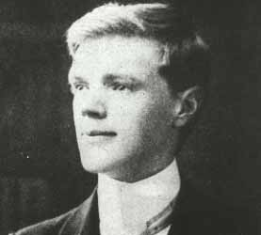
D.H. Lawrence(1885-1930):
.Sons and Lovers
.Everlasting Flowers Elegy
.Discord in Childhood
.Dolor of Autumn
.Excursion
.Lady Chatterley's Lover
.Women in Love

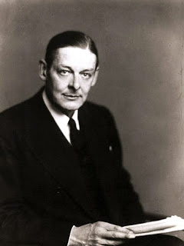
T.S.Eliot(1888-1965):
.The Love Song of J. Alfred Prufrock.
.Gerontion Sweeney Among the Nightingales
.The Waste Land
.The Hollow Men
.The Journey of the Magi
.Ash Wednesday

1945- Postmodern and Contemporary Period

