* **For an action completed at a stated time in the past**  
  *He finished his homework at 7o'clock.*
* **For actions which happened one after another (sequence of actions*)****She got up, had a shower, get dressed and went to work.*
* **With non-continuous verbs** (e.g.: believe, belong, cost, feel, forget, hate, have, know, like, love, mean, need, prefer, realise, remember, see, sound, suppose, taste, think, understand, want)  
  *He wanted to buy a new sports car but he couldn't afford one.*
* **For past actions which won't happen again**  
  *Shakespeare wrote a lot of plays.*
* **For an action that was in the middle of happening at a stated time in the past***At 8 o'clock last night she was watching TV.*
* **For two or more actions which were happening at the same time in the past (simultaneous actions)***While Rabbit was explaining, Winnie-the-Pooh was thinking of honey, Piglet was staring at the ground and Owl was tearing his hair.*
* **For a past action which was in progress when another action interrupted it***He was cleaning the window when suddenly he noticed the butterfly in the window frame.*
* **To describe the background to the events in a story.**  
  *We were walking in the woods. The sun was shining, the birds were singing…*



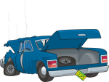

1. **Make sentences using the information in the table.**

1. *William Black was going to the gym when he saw the accident.*
2. _____________________________________  
   _____________________________________
3. _____________________________________  
   _____________________________________
4. _____________________________________  
   _____________________________________
5. _____________________________________  
   _____________________________________
6. _____________________________________  
   _____________________________________
7. _____________________________________  
   _____________________________________
8. _____________________________________  
   _____________________________________

**name activity accident/event**

**1** William Black go to the gym see the accident

**2** The Browns drive to Totnes car break down

**3** Thomas Stevens climb a mountain break his leg

**4** Dorothy Harrods cook dinner cut her hand

**5** Judy & Tim swim in the sea start rain

**6** Mr Smith walk in the forest fall down

**7** Lucy jog get cramp

**8** The children play football break the window

2. **Make sentences about these simultaneous activities.**

Kevin & Ian Mrs West & Mr West Kim & Suzie

1. *While Kevin was playing the guitar,*


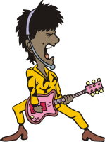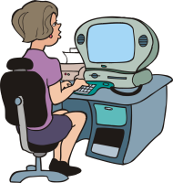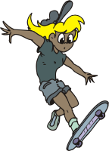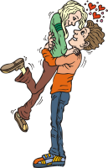

3. **Underline the correct verb form.**

* They ***met/were meeting*** when they ***lived/were living*** in France.
* She ***baked/was baking*** a cake when suddenly the door ***opened/was opening***and her daughter ***rushed/was rushing*** in.
* He ***stood/was standing up***, ***walked/was walking*** across the room, and   
  ***closed/was closing*** the door.
* A strange man ***walked/was walking*** into the building. He ***wore/was wearing*** purple trousers and a yellow shirt.
* I ***saw/was seeing*** you at the party yesterday. You ***sat/were sitting*** in the garden with Samantha.
* Why ***didn’t they visit/weren’t they visiting*** Hampton Court Palace while they ***stayed/were staying*** in London?

4. **Finish the sentences.**

* He was lying in the hammock when
* I was walking down the garden path when
* I was in the middle of hanging out the washing when
* I was reversing the car out of the garage when
* He was climbing the apple tree when
* While we were sunbathing on the beach

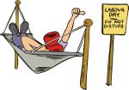

5. **Put the verbs into the correct form. Then match the verbs in bold to the pictures.**

The other day I *(have)* ____________________ a strange dream. I *(dream)* ____________________ that I was a princess who *(not do)* ____________________ any housework. Five men servants *(do)* ____________________ it all! I *(dream)* ____________________ that while I *(sit)* ____________________ in the shade, Philip *(****sweep****)* ____________________ the drive! While I *(read)* ____________________ the newspaper, William *(****vacuu****m)* ____________________ the carpets! While I *(have)* ____________________ tea on the patio, Henry *(****prepare****)* ____________________ the lunch! While Jonathan *(****do****)* ____________________ the washing up, I *(watch)* ____________________ a football match! And while I *(drink)* ____________________ beer in the lounge, Jack *(****wash****)* ____________________ the floor. Wasn't that a wonderful dream!

Then I *(wake up)* ____________________. I *(realise)* ____________________ that while I *(dream)* ____________________, I should have done the housework!

