1



2

Go and shear the sheep.

3

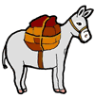

4

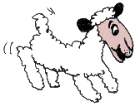

5

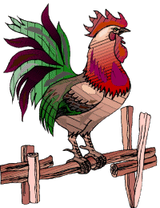

6



7



8

Take the dog for a walk.

9

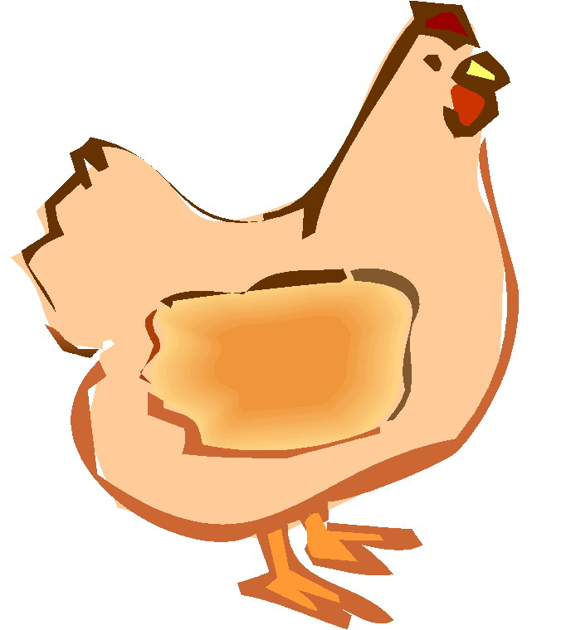

10



11

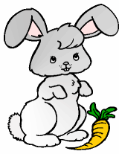

12

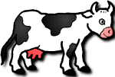

13

Go for a ride.

14



15

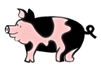

16

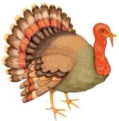

17

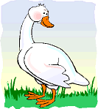

18



19

Go to the hen and fetch some eggs.

20

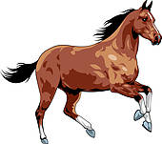

21



22

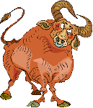

23

Your tortoise is missing. Go and look for it.

24

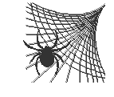

25



26

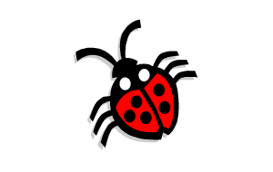

27

It’s Thanksgiving. Go and bring the turkey into the kitchen.

28

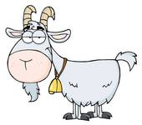

29

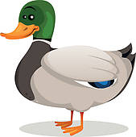

30

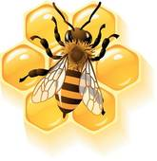

HOME

1 DOG



2

Go and shear the sheep.

3 DONKEY



4 SHEEP



5 ROOSTER



6 MOUSE



7 CAT



8

Take the dog for a walk.

9 HEN



10 HAMSTER



11 RABBIT



12 COW



13

Go for a ride.

14 FISH



15 PIG



16 TURKEY



17 GOOSE



18 TORTUE



19

Go to the hen and fetch some eggs.

20 HORSE



21 GRASSHOPPER



22 BULL



23

Your tortoise is missing. Go and look for It.

24SPIDER



25 FROG



26 LADYBUG



27

It’s It’s Thanksgiving. Go and bring the turkey into the kitchen.

28 GOAT



29 DUCK



30 BEE



HOME

**Instructions for the teacher.**

**Preparation**

* Print the board games on tick paper or a cardboard; laminate them if you want to use them many times.
* Find tokens for each student.
* Provide dice.
* Divide the class into groups of 3 – 4 students each.
* Give each group a board game and a die.
* Give each student a token (or bean, coin, button, etc.).

**The game**

* The players put their tokens on the square Number 1.
* The first student throws the die and moves his token ahead the corresponding number of squares.
* The student says the name of the animal according to the picture or follows the instructions and goes to the mentioned word..
* **Example: This is a brown dog.**
* If the answer is correct, the student stays, if the answer is incorrect, he has to go back where he came from.
* The first student who takes a number that places his token on “home” or surpasses it is the winner.