THE LION and The MOUSE
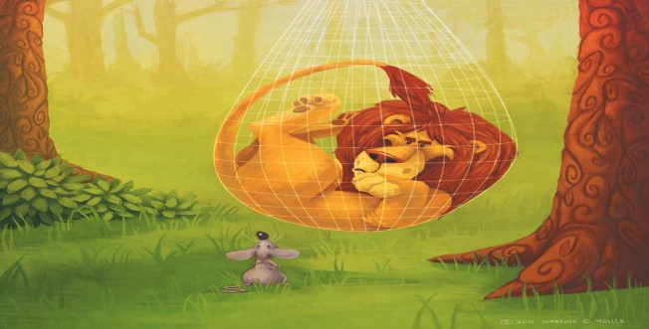
A lion was sleeping one day when a little mouse climbed up his face. The little mouse ran up and down on his face . The mouse woke the lion up and the lion got very angry .
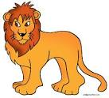 He caught the mouse and said : “ What are you doing over my face?”. He opened his big mouth to eat the mouse.
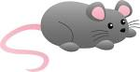 “Oh, do not kill me ,Mr. Lion .” said the mouse . “ I didn’t mean to woke you up. Let me go.”
“ No, I will not let you go.” said the lion.
The mouse was afraid of the lion and said “ If you let me go, I’ll do something for you later.”
This made the lion laugh. “ What a joke! well you are too little to eat , so I will let you go this time , but don’t come here again.” Said the lion. He let the mouse go.
While the mouse was running away it said “ thank you kind lion, I will not forget your kindness .”
One day a hunter caught the lion. The hunter tied him to a tree and he went to get his car to carry him away .
The lion roared so loud that the little mouse heard him.
“That lion is in trouble I will help him .” It said and it ran to the lion.
When the mouse saw the lion , he said “ Mr. Lion, be quiet, I’ll set you free ”.
“ You are not strong enough to help me !” said the lion hopelessly.
“I’m strong enough to help you. Don’t worry !” said the mouse.
The mouse chewed the rope hard, so it tore apart the rope. Finally , he saved te lion.

- Read the story and decide : “ What is the main idea of this story?”
What is the main idea of the story?
It’s easy to catch the lion. The mouse was fat but it could run.
The lions likes walking. A little mouse can be a big help.

- Read the story again and tick “√” the correct choice.

What did the mouse do for the lion?
She ran to get help She sang a song for him
She let him out of the net She gave him some food

A: Why did the lion roar ?
B: Because, _ _ _ .

He wanted to scare the mouse He wanted help
He was hungry He didn’t like the mouse.

What did the lion think when he saw the mouse again ?
The mouse was fat The mouse was too little to help
The mouse was sad The mouse did not know who to help
circle
- Read, Decide and the correct option.

- The mouse was afraid of lion said , “ if you let me go, I’ll do something for you later.”
“ be afraid of lion” means “let someone go” means
- being filled with fear of the lion . a) to stop holding someone or something
- being filled with confidence of the lion. b) to end someone’s friendship

- This made the lion laugh. “ What a joke! Well, you are too little to eat. So,I will let you go this time, But don’t come here again.” said the lion.

“ What a joke! ” means

- it was a good joke
- it was a bad joke

- While the mouse was running away, it said “ Thank you , kind lion. I will not forget your kindness.”
“ to run away ” means “kindness” means
- to leave a person or a place suddenly a) to be gentle and polite
- to walk in the jungle with someone b) to be rude and bossy

- One day a hunter caught the lion. The hunter tied him to a tree and he went to get his car to carry him away.

“tie someone to a tree” means “ carry someone away” means

- to throw somebody to a tree a) to take or steal someone
- to fasten somebody to a tree b) to call someone

- When the mouse saw the lion, he said ,“ Mr Lion, be quiet and I’ll set you free.”
“set someone free” means
- to release someone from something.
- to defend someone from something.

- The mouse chewed the rope hard, so it tore apart the rope .

“tear something apart” means

- to eat or swallow something
- to pull or rip something apart

- Look at the box and decide : “What are the personal qualities of the lion?” and “What are the personal qualities of the mouse?”
friendly hardworking bad-tempered optimistic honest kind proud
decisive pessimistic helpful rude selfish good-tempered

What is the lion like? What is the mouse like?

- Strengths

- Weaknesses

The lion has The mouse has
- Strengths

- Weaknesses

Strengths show a person’s
a) positive qualities.
b) negative qualities.

Weaknesses show a person’s
- positive qualities.

- negative qualities.

