UNIT 5 COMMUNICATION TEOG EXAM
My brother is an internet addict in our family. He uses the internet 7 or 8 hours a day. He does many things online on his tablet pc or smart phone. However, he doesn’t talk to us or never spend time with us.

- Parçada aşağıdaki sorulardan hangisinin cevabı yoktur?

- Who uses the internet most in your family?

- How does your brother access theinternet?

- How many hours a day does he use the internet?

- Does he usually do live chat with his friends on the net?

- Daniela : ………
Brad : I can take it everywhere with me . I can use it on the bus or at a café.

- Do you use a desktop pc?

- Why do you use a tablet pc?

- How many hours do you spend online?

- How do you connect to the Internet?

- Martin : ……………
Kevin : Several times a week

- How often do you check your e mail?

- Are you always online?

- How many hours do you spend online?

- How are things?
I’m unavailable at the moment. I hope you can find someone else to help you.
How do you connect to

Gina

Pam

Margaret
Why not. But, you should hang on a few minutes. I’ll get back sooner.
I’d love to , but I’m working on my project. May be another time.
Sue : Hi! My dear buddies. I have a connection problem with my desktop pc. Are you free? Can you help me, please?

- According to the conversation , …..

- Sue has a problem with her account.

- Margaret is not busy and she can help Sue.

- Pam accepts to help her in a few minutes.

- Gina doesn’t know how to help Sue.

- Who has an excuse not to help Sue?

- Pam b) Gina c) Margaret d) Tina

- If you want to register in a social networking site , you should create a/an ………. first.

- comment c) attachment

- account d) web browser

- Şirin : ………. .

Betty : I get news ,do shopping online and search for information .

- When do you usually surf on the net?

- Why do you prefer staying alone?

- What do you usually do online?

- How many hours do you spend online?

- Pam : Do you use a cable modem or wireless modem ?
Sue : Wireless modem.
Pam : Check the connection sign on your modem first ?
Sue : ………….
Pam : Is the connection sign red or green on your modem ?
Sue: It’s red.
Boşluğa uygun ifadenin bulunduğu seçeneği işaretleyiniz.
- Is your pc online of offline?

- What do you mean?

- Is the internet conneciton sign on modem?

- Why don’t you restart your modem?

You can ___ a web site entering your username and password.

- hang on c) confirm

- log out d) sign in

- What are the missing parts of this computer ?

- speakers – monitor – keyboard

- system unit – mouse - touchpad

- headphones – speakers - webcam

- keyboard - headphones – Mouse

- I. Internet addicts are always online.
II. They use their desktop PCs, laptops,
tablets or smartphones to connect to the Internet. III. They are not so good at face-to-face interaction. IV. They think and talk about the Internet all the time. V. They have many Internet friends.

Numaralandırılmış cümlelerden anlam akışını bozan cümlenin bulunduğu seçeneği işaretleyiniz.

- II b) III c) IV d) V
- Expert : ……..

Counsellor : They are bad at socializing şn person and and they usually have
Problems with their families, friends and schools.

- How many Internet users are addicts?

- What are some things Internet addicts do?

- What problems do Internet addicts have?

- Do Internet addicts spend lots of time online?

Some Internet sites allow you to create online
identities. By using these identities you can chat,
share photos and tell people about yourself. They
are known as social networking sites because you
can make online friends through these sites.

- According to text , …..

- You can’t register in social networking sites .

- You can’t make live chats with other people.

- You can not make new friends .

- You can share your private life online.
…………………………………………
- Use the safe sites.
- Don’t share your password with anyone except your parents.,
- Be careful with what you share.
- Choose your online friends.
- Tell your parents if you see bad online behavior

14 ve 15. Soruları listeye göre cevaplayınız.
- What is the best title for this list.

- Internet Safety Rules

- Why do we use the internet

- Social Networking Sites

- Making Friends Online

- Which one is false according to the list?

- You should never care about what you share.

- You should share your password only with your parents.

- You should choose your online friends carefully.

- You should get some help of your parents when you have a problem .
- Counsellor : Friends on the net are not the same as real in-person friends. Never agree to meet an online friend in person. This is dangerous because some people pretend to be your age online, but actually they are adults.

Sally : That’s ok. Thanks a lot. I will be careful.

Konuşmaya göre danışman Sally için hangi konuda bilgilendirme yapmaktadır?

- Internet Habits c) Online Friends

- Safe Sites d) Internet bahaviours
17,18 ve 19. soruları tabloya göre cevaplayınız.
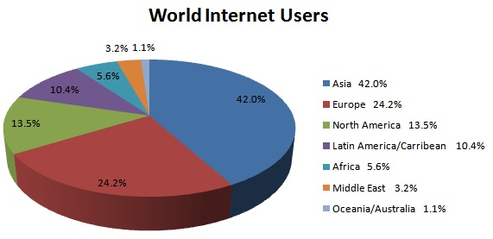

- According the chart , ……. .

- Europe has the most internet users .

- Latin America has the least internet users.

- North America dominates the others with %42 internet user rate .

- Asia’s internet users dominate the other continents.

- Which on is false according to the text ?

- Nearly 6 in 10 people in Asia don’t use the internet.
- Lots of people in Australia use the internet every day.
- North America has more internet users than Africa .
- Nearly 24 people in 100 in Europe use the internet.

- Tabloya göre aşağıdaki sorulardan hangisine
cevap verilemez ?

- What region has the most Internet users?

- What is the source of the information?

- What geographical regions are there in the chart?

- What is the chart about?

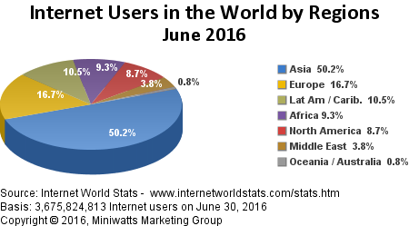

- Tabloya göre aşağıdaki sorulardan hangisine cevap verilemez ?

- What is the year of the information in the chart?

- What is the source of the information?

- What region has the most Internet users?

- How many people use the Internet in Australia?

