NAME: ...............................................................
SCHREIBE!
ICH HEIßE MINNIE. WIE HEIßT DU?
..............................................................................
ICH ......................
........................................................
....................................................................................

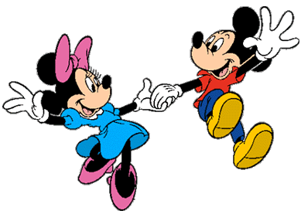
WIE SPÄT ...........?
ES IST ...................

WIE .............................?

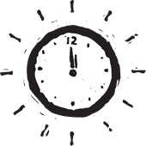
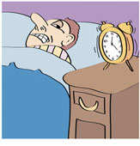
ES ............
.................
SCHREIBE DIE RECHNUNGEN!
- 2 + 6 = ZWEI PLUS SECHS IST ACHT
- 9 + 3 = .....................................................................................................................................
- 1 + 5 = .....................................................................................................................................
- 10 – 5 = ZEHN MINUS FÜNF IST FÜNF
- 8 – 3 = ....................................................................................................................................
- 14 – 3 = ...................................................................................................................................
- 20 – 10 = .................................................................................................................................
- 11 + 4 = ..................................................................................................................................
WIE SPÄT IST ES?
- 2:00 ES IST ZWEI UHR.
- 10:00 ...................................................................................................................................
- 3:00 ....................................................................................................................................
- 7:00 ....................................................................................................................................
- 8:00 ....................................................................................................................................
- 12:00 ..................................................................................................................................
- 1:00 ....................................................................................................................................
- 4:00 ....................................................................................................................................
- 6:00 ....................................................................................................................................

