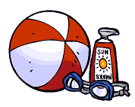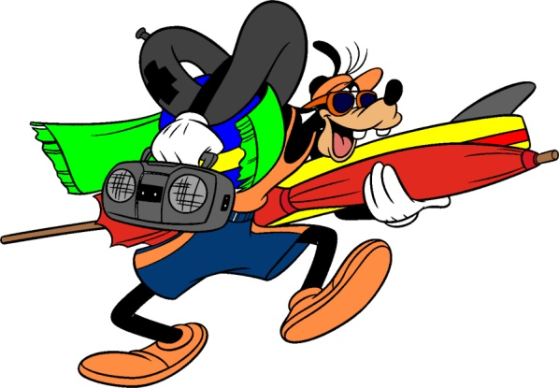

1. A promenade or walk made of planks along a beach or water front.

2. Large and light ball to play at the seaside.

3. A coastal aquatic bird.

4. A “fish” with a nearly transparent body and tentacles.

5. Something you can wear on your head.

6. A nice treat on a hot day!

7. An expert swimmer employed at a beach.

8. A candy of molasses; soft and chewy.

9. To collect shells or fossils.

10. A hill of sand piled up by the wind.

11. What you have when you have got too much sun.

12. A moving ridge of the surface of the water. (WAVE)

13. The land along the edge of body of water. (SHORE)

14. A shoe: a sole strapped to the foot.

15. What you apply to your skin to avoid a sun burn.

16. A marine mollusk with a spiral shell.

17. The upward and downward movement of the sea caused by the pull of the Moon and the Sun on the Earth.

18. What people like to have when they go on the beach.



T

R

1. A promenade or walk made of planks along a beach or water front.

2. Large and light ball to play at the seaside.

3. A coastal aquatic bird.

4. A “fish” with a nearly transparent body and tentacles.

5. Something you can wear on your head.

6. A nice treat on a hot day!

7. An expert swimmer employed at a beach.

8. A candy of molasses; soft and chewy.

9. To collect shells or fossils.

10. A hill of sand piled up by the wind.

11. What you have when you have got too much sun.

12. A moving ridge of the surface of the water. (WAVE)

13. The land along the edge of body of water. (SHORE)

14. A shoe: a sole strapped to the foot.

15. What you apply to your skin to avoid a sun burn.

16. A marine mollusk with a spiral shell.

17. The upward and downward movement of the sea caused by the pull of the Moon and the Sun on the Earth.

18. What people like to have when they go on the beach.

E

D

T

N

H

C

N

O

N

E

R

E

C

S

S

U

S

A

D

A

L

L

G

S

U

N

B

N

U

E

N

D

G

N

I

L

L

E

H

Y

F

F

A

T

R

E

T

S

A

L

T

W

A

D

R

A

U

G

L

I

F

M

A

E

R

C

E

C

S

U

N

T

A

H

S

I

F

Y

L

L

J

B

E

A

C

H

B

A

L

K

L

A

W

D

R

A

O

B