Clues

1. Something you can use to type on and go online on.
2. Where you find countries on.
3. What a student sometimes wear to school.
4. What you do at school.
5. What you write with.
6. What American people call the break between two lessons.
7. What you have to see how well you have studied.
8. You read in them.
9. A period away from school.
10. What you use to write on the blackboard.
11. A student sits at this.
12. Books are made up of these.
13. What students shouldn’t make!
14. You use it in Maths.
15. What is “Bend It Like Beckham”? A ………..!
16. What you should take during lessons.
17. American for rubber.
18. You find many of these in books.
19. It is white and comes in sheets.
20. What students often ride to get to school in America.
21. Another word for a group of friends.

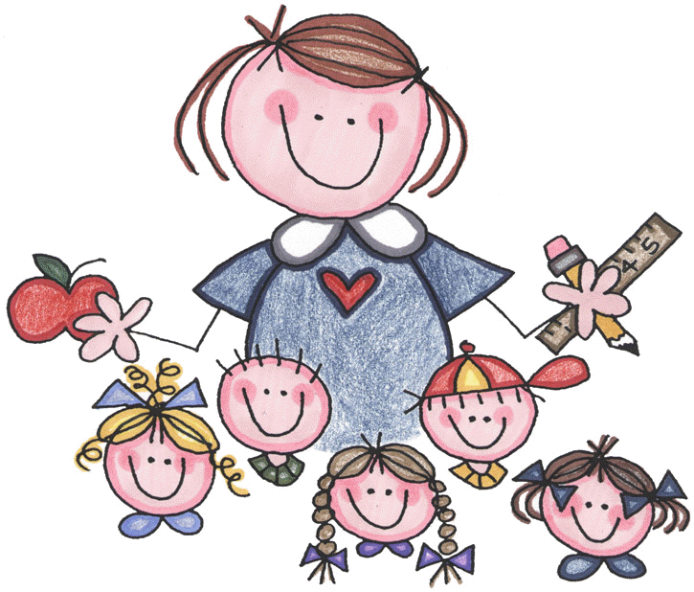

Mia: “I think we need a new teacher”

Mum: “Why is that?”

Mia: “Our teacher doesn’t know anything she keeps……”

______________________________________________________