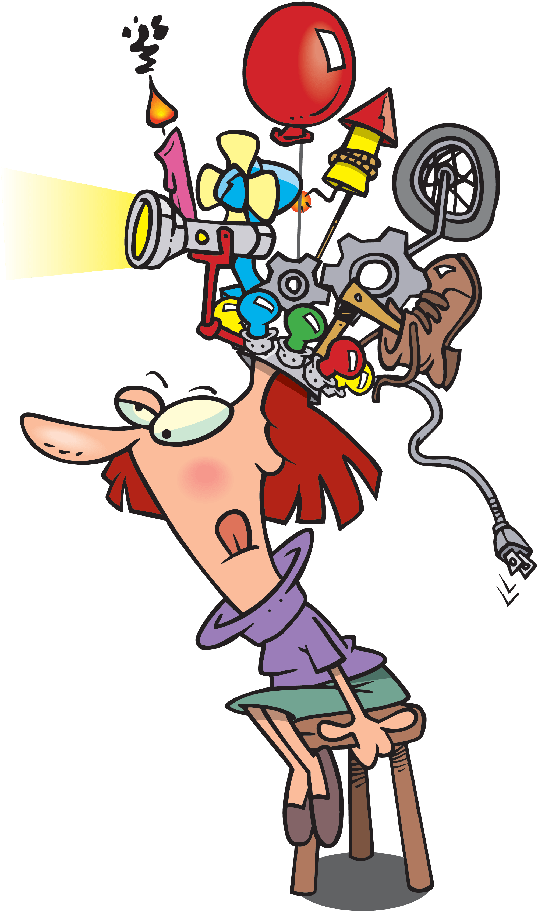



**Weird sentences**

Read the sentences and explain why they are weird.

1.No one goes to that restaurant because it is very crowded.

2.I will never eat spinach because it tastes awful.

3.If you can’t read this sentence,you should ask for help.

**Solution:**

**Everyday chores**

A girl is at home at night.There was no light,no candle,no lamp.It was dark but the girl can

clean the house.How?

**Solution:**

**Find the bone**

The dog buried the bone in the garden.He doesn’t remember the place.Under the rock,in the

garden,under the porch or under the tree? There are 4 sentences but only one sentence is

true.Where is the bone?

1.The bone is under the rock.

2.The bone is in the garden or under the tree.

3.The bone is under the rock or under the porch.

4.The bone is not in the garden.

**Solution:**

**Getting younger and younger**

In the year 1201,a woman was 35 years old.In the year 1206,the woman was 30 years old.

How?

**Solution: **

**Mistakes?**

There are two mistakes in this sentense. What are the mistakes?

**Solution:**

**Mystery twins**

Two babies have the same mother and farther.They were born on the same day in 2015.But

they are not twins.Explain how.

**Solution:**

**The barbershop puzzle**

The traveler arrives in a small town.He wants to go to a have a haircut.There are only two b-

arbershops in the town: on East street and on West street.The East Street barbershop is in

a mess and the barber has a terrible haircut.The West Street barber shop is neat and clean,

the barber has a great haircut.Where should the traveler go and why?

**Solution:**

**Zoo favourites**

Dan, Jen, Keith, and Mia are going to the zoo.Each kid wants to see his/her favourite ani-

mal.There is the deer, the lions, the leopards or the giraffes.Dan doesn’t like cats and animals in cat family.Jen’s favourite animal doesn’t have horns.Keith’s favourite animal

doesn’t have spots.Mia disagrees with Dan and Keith.What are the kid’s favourite animals?

**Solution:**

**What a genius!**

Wanda and Ralph are at school and they are talking about geniuses.Ralph says: ‘’All genius people have bad handwriting.’’ Wanda says:’’Hey! I have terrible handwriting so I am a genius too!’’ Is Wanda a genius? Why or why not?

**Solution:**

**ANSWER KEY**

**Getting younger and younger:** The dates are B.C. rather than A.D.

**Weird sentences:** If no one goes to the restaurant, it can't be crowded.

If the person has never eaten spinach,he/she can’t know how it tastes.

If the person can't read the sentence, she or her won't know that it says to ask for help.

**Mistakes?:** First mistake: The second s in the wordsentenseshould be a c.

Second mistake: There is onlyonemistake in the sentence.

**Everyday chores:** The girl is blind.

**Find the bone:** The bone is in the garden.

If sentence #1 is true, then sentence #3 is also true, but only one sentence can be true, so both #1 and #3 are false-the bone is not under the rock or under the porch. That leaves the garden and the tree, so let's look at sentences #2 and #4. If sentence #2 is true, then sentence #4 is false. That would leave us with just 1 true sentence, but is the bone in the garden or under the tree? We know that sentence #4 is false, so the bone must be in the garden.

**What a genius!:** She is not a genius. The fact that Individual A shares one characteristic of a group of individuals does not logically imply that Individual A is a member of that group.

Think of it this way. If Ralph had said, "All whales are good swimmers," Wanda would probably not have thought to herself, "Hey, I've always been a good swimmer. I must be a whale!"

**Zoo favourites:** Dan's favorite animal is the giraffe, Jen's is the leopard, Keith's is the lion, Mia's is the deer.

**The barbershop puzzle:** The traveler goes to have his hair cut at the barbershop on East Street. He figures that since there are only two barbershops in town the East Street barber must have his hair cut by the West Street barber. So if the traveler wants to look as good as the West Street barber (the one with the good haircut), he'd better go to the man who cuts the West Street barber's hair-the East Street barber.

By the way, the reason the West Street barbershop is so clean and neat is that it seldom gets customers.

**Mystery Twins:** The two babies are two of a set of triplets.