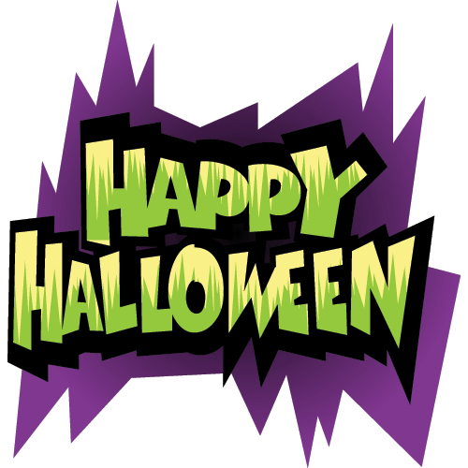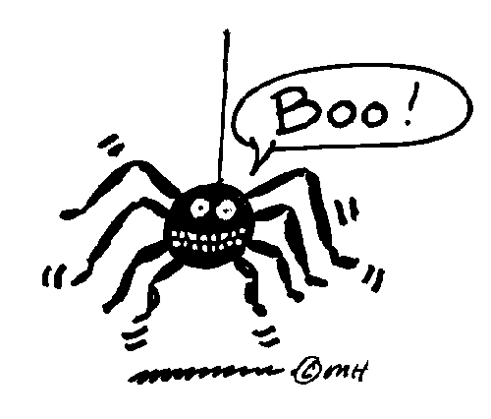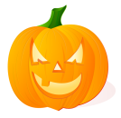

Answer of riddle:

_____________________________________________________________________________________________

Why did the ghost cross the road?

Clues

1. Vegetable you can carve.
2. Month of Halloween.
3. A ”mean” woman.
4. Opposite of light.
5. A colour of Halloween.
6. The soul of a dead person.
7. The handle of a broom.
8. A large kettle.
9. It is made by a spider.
10. An animal related to Halloween.
11. The skeleton of the head.
12. A box to hold a dead body.
13. A spoken word believed to have magic power.
14. A hole dug to bury a dead body in.
15. Opposite of day.
16. Opposite of alive.
17. To pull with effort.
18. Trick or ……………!

